REQUEST FOR Expressions of Interest
in relation to THE ACARA corporate website BUILD

Australian Curriculum Assessment and Reporting Authority (ACARA)
ABN 54 735 928 084

Contents
1. Introduction 1
2. Obtaining REOI documentation 2
3. Lodging Expressions of Interest 2
4. Additional information and variations to the REOI documentation 3
5. Information management 4
6. Policy and law 5
7. Matters concerning EOI response 8
8. General matters 10
9. Evaluation of EOIs 12
10. Other Matters 13
Schedule 1 - Requirements 15
1.1 About the project 15
1.2 Program Background 15
1.3 ACARA and NAP websites overview 16
1.3.2 NAP website 18
1.5 Architectural and design principles 20
1.6 Strategy Support 20
1.7 Detailed design for NAP website (optional) 21
1.8 Development and testing of the ACARA website 21
1.9 Change Management 22
1.10 Post Live Support / Handover 23
1.11 Mandatory Criteria 23
1.12 Statement of Requirements – Evaluation Criteria 23
1.13 Indicative timing 23
Schedule 2 - EOI RESPONSE FORMS 24
Attachment 1: Respondent's Details 24
Attachment 2: Respondent’s Deed 26
DEED POLL 26
Context 26
Interpretation 26
Compliance with REOI 26
Offer 26
Confidentiality 26
Ethical Dealing 26
Conflict of Interest 27
Employee entitlements 27
Compliance with Australian standards 27
Indigenous Procurement Policy 27
Workplace Gender Equality Requirements 27
Attachment 3: Response against the Mandatory Criteria 29
Attachment 4: Response against Evaluation Criteria 29
Attachment 5: Indicative Cost 29
Appendices 30
Appendix 1: List of templates and links to high-level designs in PDF 30
Appendix 2: List of components and link to high-level designs 31
Appendix 3: User journeys 32
Appendix 4: New acara.edu.au IA 33
Appendix 5: ACARA Digital Vision 34
Appendix 6: Digital Channel Foundations program benefits 35
Appendix 7: ACARA Strategic Priorities 36

Request for Expressions of Interest

  - Introduction
    - Request for Expressions of Interest
      - ACARA invites Expressions of Interest (EOIs) for the provision of the ACARA corporate website in accordance with this Request for EOI (REOI).
      - Respondents should note that this is not a request for tender. However, ACARA may invite some or all Respondents to this REOI to participate in a subsequent tender process (noting paragraphs 7.3 and 9.5 below). A failure to respond to this REOI may result in a potential supplier not being invited to participate in any subsequent tender process.
      - A summary of ACARA and the requirement for the ACARA Corporate Website Build is set out in Schedule 1 of this REOI. Associated documents can be found in the appendix.
    - Key terms
      - The following table sets out the details of some key terms used in this REOI:
ACARA | Australian Curriculum Assessment and Reporting Authority
Closing Time | 3pm Sydney time on 8 May 2024
Contact Officer | Adam Larkins  Adam.Larkins@ACARA.edu.au
Deadline for Submission of Respondents’ Questions | 3pm Sydney time on 1 May 2024
Expression of Interest or EOI | any Expression of Interest submitted in response to this REOI
REOI Details | The name of this REOI is “Request for Expressions of Interest in relation to the ACARA Corporate Website Build
Respondent | any entity which submits an EOI or, where the context requires, is proposing to submit an EOI
Services | the services set out in Schedule 1
Tender Box | By email:  Private and Confidential  REOI in relation to the ACARA Corporate Website Build.  Adam Larkins  Adam.Larkins@acara.edu.au, with a carbon copy (cc) to procurement@acara.edu.au
    - Governing law

This REOI is to be construed in accordance with, and any matter related to it is to be governed by, the law of New South Wales. The courts of that State have non-exclusive jurisdiction to decide any matter related to this REOI.
  - Obtaining REOI documentation
    - REOI available on ACARA’s website.
    - https://www.acara.edu.au/about-us/tenders
      - Respondents should regularly check ACARA’s website for updates and addendum to the REOI.

  - Lodging Expressions of Interest
    - Lodgement and EOI Closing Time
      - EOIs must be lodged by email on or before the Closing Time.
      - ACARA may extend the Closing Time and will issue an addendum notifying any decision to extend.
    - Electronic lodgement
      - The time displayed on ACARA’s email system as the time the EOI is received by ACARA is deemed to be the current time and will be the means by which ACARA will determine whether an EOI has been lodged by the Closing Time. Respondents will be issued with a receipt with the date and time that the EOI was received.
      - The judgement of ACARA as to the time an EOI was received will be final.
      - ACARA will accept EOIs lodged in a format compatible with Microsoft Office.
      - EOI files should not exceed a combined file size of 2 megabytes total.
      - EOIs must be completely self-contained. No hyperlinked or other material may be incorporated by reference.
      - If ACARA requires clarification of a lodged EOI, the Respondent may be required to courier or security post the originals of signed and/or initialled pages to ACARA addressed to the Contact Officer and within the timeframe specified by the ACARA.
    - Late lodgement policy
      - Any EOI (including an EOI already received by ACARA at a point other than the nominated email address) will be deemed to be late if it is not lodged in accordance with paragraph 3.1.
      - Late EOIs will not be admitted.
  - Additional information and variations to the REOI documentation
    - Requests for Additional information
      - Requests for further information in relation to this REOI should be directed in writing to the Contact Officer by the Deadline for Submission of Respondents’ Questions.
      - Subject to paragraph 7.4 the only point of contact for all matters relating to this REOI and the REOI process is the Contact Officer.
      - ACARA will determine what, if any, response should be given to a Respondent question. ACARA may circulate Respondent questions and ACARA’s response to those questions to all other Respondents without disclosing the source of the questions or revealing any confidential information of a Respondent. Respondents should identify in their question what, if any, information in the question the Respondent considers is confidential. Inappropriate identification of information as confidential will be considered by ACARA when determining what, if any, response will be given.
      - If a Respondent believes it has found a discrepancy, error, ambiguity, inconsistency, or omission in this REOI or any other information given or made available by ACARA, the Respondent should promptly notify the Contact Officer setting out the error in sufficient detail so that ACARA may take the corrective action, if any, it considers appropriate.
    - Variation of the REOI
      - ACARA may amend this REOI or vary or suspend or the REOI process at any time, including but not limited to the timeframes and dates set out in this REOI. If ACARA does so prior to the Closing Time, ACARA will issue a formal addendum to the REOI available on the ACARA website (https://www.acara.edu.au/about-us/tenders).
    - Termination of the REOI
      - ACARA may terminate the EOI process at any time at ACARA’s sole discretion.
      - Respondents should ensure that any errors or alterations made to an EOI are clearly identified and, where appropriate, initialled. Any alteration or erasure made to an EOI that is not clearly identified may result in the EOI being excluded from consideration.
      - EOIs in which prices are not clearly and legibly stated may be excluded from consideration.
      - If ACARA considers that there are unintentional errors of form in an EOI, ACARA may request Respondents to correct or clarify the error but will not permit any material alteration or addition to the EOI.
  - Information management
    - ACARA’s confidential information
      - Respondents must not and must ensure that their employees, agents or subcontractors do not, either directly or indirectly record, divulge or communicate to any person any confidential information concerning the affairs of ACARA, the Commonwealth or a third party acquired or obtained in the course of preparing an EOI, or any documents, data or information provided by ACARA and which ACARA indicates to Respondents is confidential or which Respondents know or ought reasonably to know is confidential.
      - ACARA may require that all written information (whether confidential or otherwise and without regard to the type of media on which such information was provided to Respondent) provided to Respondents (and all copies of such information made by Respondents) be:
- returned to ACARA - in which case Respondents will be required to promptly return all such information to the address identified by ACARA; or
- destroyed by Respondents - in which case Respondents will be required to promptly destroy all such information and provide ACARA with written certification that the information has been destroyed.
      - ACARA may exclude from further consideration any EOI lodged by a Respondent who has engaged in any behaviour contrary to paragraph 5.1.
    - Respondent’s confidential information
      - Subject to paragraphs 5.2.2, ACARA will treat as confidential all EOIs submitted by Respondents in connection with this REOI.
      - ACARA will not be taken to have breached any obligation to keep information provided by Respondents confidential to the extent that the information:
- is disclosed by ACARA to its advisers, officers, employees or subcontractors solely in order to conduct the REOI process or to prepare and manage any resultant contract;
- is disclosed to ACARA’s internal management personnel, solely to enable effective management or auditing of the REOI process;
- is disclosed by ACARA to the responsible Minister;
- is disclosed by ACARA in response to a request by a House or a Committee of the Parliament of the Commonwealth of Australia;
- is shared by ACARA within ACARA’s organisation, or with a Commonwealth ACARA, where this serves the Commonwealth’s legitimate interests;
- is authorised or required by law to be disclosed; or
- is in the public domain otherwise than due to a breach of the relevant obligations of confidentiality.

Respondents should also refer to paragraphs to b to d.
    - Use of EOI documents
      - All EOIs become the property of ACARA upon submission.
      - Notwithstanding paragraph 5.3.1 and without prejudice to anything agreed in any subsequent contract, ownership of intellectual property in the information contained in an EOI remains unchanged.
      - However, ACARA may use any material contained in an EOI, or otherwise provided by the Respondent, for the purposes of the REOI process, any related tender process and the preparation and management of any resultant contract.
  - Policy and law
    - Ethical dealing
      - The Commonwealth’s policy is to promote the ethical use of Commonwealth resources and to engage in ethical behaviour throughout its procurement processes. The Commonwealth requires the same standards from those with whom it deals.
      - EOIs must be compiled without improper assistance of employees or former employees of ACARA and without the use of information improperly obtained or in breach of an obligation of confidentiality.
      - Respondents must not:
- engage in misleading or deceptive conduct in relation to EOIs or the REOI process;
- engage in any collusive Tendering, anti-competitive conduct, or any other unlawful or unethical conduct with any other Respondent, or any other person in connection with the preparation of their EOI or the REOI process;
- attempt to solicit information from or influence improperly any current or former officer, employee, contractor or agent of ACARA, or violate any applicable laws or Commonwealth policies regarding the offering of inducements in connection with the REOI process;
- engage in, or procure or encourage others to engage in, activity that would result in a breach of the Lobbying Code of Conduct and APSC Circular 2008/4 Requirements relating to the Lobbying Code of Conduct and post separation contact with Government; or
- otherwise act in an unethical or improper manner or contrary to any law.
      - ACARA may exclude from consideration any EOI lodged by a Respondent that has engaged in any behaviour contrary to paragraph 6.1. In addition, ACARA may refer the matter to relevant Commonwealth, State or Territory authorities. This right is in addition to any other remedies ACARA may have under law or in any contract with a successful Respondent.
    - Conflicts of interest
      - Respondents should represent and declare in Attachment 2: Respondent’s Deed in Schedule 2, whether, at the time of lodging their EOI, a conflict of interest concerning itself or a related entity exists, or might arise during the term of any contract entered in connection with the EOI or in relation to the EOI.
      - A conflict of interest means any matter, circumstance, interest, or activity affecting the Respondent (including the officers, employees, agents and subcontractors of the Respondent) which may or may appear to impair the ability of the Respondent to perform the contract diligently and independently.
      - A conflict of interest may exist if:
- the Respondent or any of its personnel have a relationship (whether professional, commercial or personal) with ACARA’s personnel involved in the evaluation of EOIs; or
- the Respondent has a relationship with, and obligations to, an organisation which would affect the performance of the contract or would bring disrepute to or embarrass ACARA.
      - If at any time prior to entering into the contract, an actual or potential conflict of interest concerning itself or a related entity arises or may arise for any Respondent, that Respondent should immediately notify the Contact Officer.
      - If a conflict of interest arises, ACARA may:
- exclude the EOI from further consideration;
- enter into discussions to seek to resolve the conflict of interest; or
- take any other action it considers appropriate.
    - Application of law and Commonwealth policy
      - Respondents are considered to have familiarised themselves with all relevant Commonwealth legislation and policies relating to the REOI process and provision of the Statement of Requirements including;
- Division 137.1 of the Criminal Code which makes it an offence to knowingly provide false or misleading information to a Commonwealth entity;
- the Freedom of Information Act 1982 (Cth) which requires Australian Government departments and agencies to provide access to certain documents in their possession;
- the Auditor-General Act 1997 (Cth) which allows the Auditor-General to conduct a review or examination, at any time, of any aspect of the operations of Australian Government agencies;
- the Ombudsman Act 1976 (Cth) which authorises the Ombudsman to investigate the administrative actions of Australian Government departments and agencies and to investigate the actions of certain Australian Government contractors;
- the Privacy Act 1988 (Cth) which aims to ensure that contractors and their subcontractors do not engage in an act or practice that would breach of an Australian Privacy Principles under the Privacy Act if done by the Commonwealth. The Privacy Act also imposes obligations directly on contractors and subcontractor;
- the Government Procurement (Judicial Review) Act 2018 (Cth) which provides a formal complaints mechanism that applies to some procurements;
- the Work Health and Safety Act 2011 (Cth) which requires a person conducting a business or undertaking to ensure the health and safety of all workers; and
- the Public Interest Disclosure Act 2013 (Cth) (PID Act) which aims to promote the integrity and accountability of the Commonwealth public sector.
      - ACARA may exclude an EOI from further consideration where the Respondent:
- has been named in Parliament as not complying with the Workplace Gender Equality Act 2012 (Cth); or
- is subject to a judicial decision against it relating to employee entitlements, not including decisions under appeal, and has not paid the claim.
- who is listed as a designated entity by the Minister for Foreign Affairs by notice in the Gazette under s 15 of the Charter of the United Nations Act 1945 or who intend to engage subcontractors who are listed as a designated entity by the Minister for Foreign Affairs by notice in the Gazette under s 15 of the Charter of the United Nations Act 1945. A consolidated list of such persons, entities and associated assets is maintained by the Department of Foreign Affairs and Trade under the Charter of the United Nations (Dealing with Assets) Regulations 2008 and can be found at https://dfat.gov.au/international-relations/security/sanctions/Pages/consolidated-list.aspx
Note: For a fact sheet on Commonwealth legislation that may apply to Australian Government contractors see
http://www.ags.gov.au/publications/fact-sheets/index.html
    - Workplace Gender Equality
      - Commonwealth policy prevents ACARA from entering into contracts with Respondents who are non-compliant under the Workplace Gender Equality Act 2012 (Cth) (the WGE Act). In performing any contract, the Respondent will be required to:
- comply with its obligations, if any, under the WGE Act; and
- if the term of the contract exceeds 18 months, provide a current letter of compliance within 18 months from the commencement date of the contract and following this, annually to the ACARA.
      - Respondents should note that, if they are successful, during the term of the contract they become non-compliant with the WGE Act, they must notify the ACARA. For further information about coverage of the WGE Act, contact WGEA on (02) 9432 7000.
      - Respondents must indicate in the Respondent’s Deed (see Attachment 2: Respondent’s Deed), whether or not they are a ‘relevant employer’ under the WGE Act and, if applicable, provide a current letter of compliance as part of their submission, or if selected as the preferred or successful Respondent, upon request from the ACARA and prior to entering into any contract.
  - Matters concerning EOI response
    - EOI response requirements
      - Respondents should provide each of the documents specified in the table below
Item | Information to be supplied | Respondent Checklist
Attachment 1 | Respondent Details
Attachment 2 | Respondent’s Deed
Attachment 3 | Responses to the Mandatory Criteria
Attachment 4 | Responses to the Statement of Requirements

    - Respondents to inform themselves
      - Information in this REOI concerning current or past requirements, volumes, location, environment or other relevant matters has been prepared from information available to ACARA and may not have been independently verified. Such information may be based on projections from information on available historical information which may not be accurate and may assume trends or events or other matters that may not be valid or eventuate as and when expected or at all. In addition, ACARA does not guarantee that this information will remain true at any future point in time.
      - ACARA has no liability to any Respondent should any information or material provided with respect to this REOI or the Services be inaccurate or incomplete or if actual volumes, locations, environments or other relevant matters vary from ACARA’s current expectations.
      - Respondents are considered to have:
- examined this REOI including any variations or addenda to the REOI, any documents referenced in this REOI and any other information made available by ACARA to Respondents for the purpose of responding to this REOI;
- examined all further information which is obtainable by the making of reasonable inquiries relevant to the risks, contingencies, and other circumstances having an effect on their EOI;
- satisfied themselves as to the correctness and sufficiency of their EOIs including any prices.
      - In preparing their EOIs, Respondents should not rely on:
- any representation, letter, document or arrangement, whether oral or in writing, or other conduct as adding to or amending these conditions other than amendments in accordance with paragraph 4.2.1; or
- any warranty or representation made by or on behalf of the Commonwealth, except as are expressly provided for in this REOI.
      - The Commonwealth will not be responsible for any costs or expenses incurred by Respondents in complying with the requirements of this REOI.
    - Disclaimer
      - ACARA is not liable to any Respondent on the basis of any contract or other understanding (including any form of contractual, quasi contractual, restitutionary or promissory estoppel rights, implied obligations or rights based on similar legal or equitable grounds) whatsoever, or in negligence, as a consequence of any matter relating or incidental to this REOI, the procurement of any or all of the requirements covered by this REOI or a Respondent’s participation in this REOI process, including instances where:
- a Respondent is not invited to participate in any subsequent process as part of or following completion of this REOI process;
- ACARA varies the REOI process;
- ACARA elects to enter into a contract for all or any of the requirements covered by this REOI with any party, whether or not that party was a Respondent in this REOI process;
- ACARA decides to terminate the REOI process or not to tender or contract for all or any of the requirements covered by this REOI; or
- ACARA exercises or fails to exercise any of its other rights under or in relation to this REOI.
    - Complaints
      - Any complaints arising out of the REOI process should be directed to the Complaints Officer:
Alexis Steffen
Alexis.Steffen@acara.edu.au

  - General matters
    - Prices and units
      - The EOI must be written in English.
      - All measurements must be expressed in Australian legal units of measurement.
      - Tendered prices should be inclusive of:
- GST (as defined in section 195-1 of the A New Tax System (Goods and Services Tax) Act 1999);
- all costs of complying with this REOI; and
- all costs associated with doing all things necessary for the due and proper completion of the proposed contract.
      - Respondents from the public sector should note that Competitive Neutrality requires that Government businesses should not enjoy net competitive advantages over their private sector competitors by virtue of public sector ownership.
      - Respondents from the public sector should demonstrate in their pricing that Competitive Neutrality requirements have been met, including:
- payment of relevant taxes and charges;
- rates of return; and
- cost of funds.
      - Australian Government policy requires Australian Government agencies to effect payment to its suppliers via electronic funds transfer direct to suppliers’ bank accounts, unless exceptional circumstances exist where a supplier has limited access to banking facilities in remote areas.
    - Joint or Part EOIs
      - ACARA will not consider joint EOIs.
      - Subject to paragraph 8.3, ACARA will not consider EOIs for only part of the requirement.
      - ACARA will not consider an EOI from a Respondent that does not exist as a legal entity at the Closing Time.
    - Alternative EOIs
      - ACARA may consider an EOI that does not comply with the Statement of Requirements at Schedule 1 ('Alternative EOI') if:
- the Respondent also lodges an EOI that conforms with Schedule 1
- the Alternative EOI:
- proposes a solution that satisfies the functionality of the Statement of Requirements, including any identified essential requirements;
- separately identifies in detail the proposed alternative approach and solution;
- clearly specifies each instance of change (including the effect of the change on the Respondent price); and
- clearly states the reasons for each instance of change and how the change is more beneficial to ACARA than the approach specified in Schedule 1.
      - Failure to provide the information requested in paragraph 8.3.1 may result in ACARA not considering the Alternative EOI.
  - Evaluation of EOIs
    - Evaluation process
      - Following the Closing Time, EOIs will be evaluated in the manner described in this paragraph 9.
      - Subject to paragraphs 9.2 to 9.5, EOIs will be evaluated against the responses to the Statement of Requirements. ACARA may take into account information provided by a Respondent in response to one requirement in its evaluation of another requirement.
      - The Statement of Requirements are not specified in any order of importance. If any additional criteria are intended to be applied in evaluating EOIs, ACARA will notify Respondents who will be given an opportunity to respond.
      - ACARA may exclude an EOI from consideration if ACARA considers that the EOI is incomplete or clearly not competitive. However, ACARA may consider such EOIs and seek clarification in accordance with paragraph 9.5.
    - Security, probity and other checks
      - ACARA may perform such security, probity and financial investigations and procedures as ACARA may determine are necessary in relation to Respondents, their employees, officers, partners, associates, subcontractors or related entities and their officers, employees and subcontractors.
      - Respondents should promptly provide ACARA with such information or documentation that ACARA requires in order to undertake such investigations. ACARA may exclude an EOI from further consideration if the Respondent does not promptly provide all reasonable assistance to ACARA in this regard, or based on the outcomes of the investigations or procedures.
      - The EOI evaluation process may involve:
- visits to some or all Respondents' sites; or
- discussions with, and/or visits to, customers or subcontractors of some or all Respondents, whether or not the customers are provided as referees by the relevant Respondent.
ACARA may make independent enquiries about any matters that may be relevant to the evaluation of an EOI.
    - Minimum Content and Format Requirements
      - Subject to paragraph 4.3.4, ACARA will exclude an EOI from further consideration if ACARA considers that the EOI does not comply with any one or more of the following requirements:
- the EOI is written in English (see paragraph 8.1.1);
- measurements are expressed in Australian legal units of measurement (see paragraph 8.1.2);
- the EOI is not a joint EOI (see paragraph 8.2.1); and
- the EOI includes a completed and signed Respondent's Deed in the form provided (see Attachment 2: Respondent’s Deed in Schedule 2.).
    - Mandatory Criteria
      - Respondents will be assessed for compliance with the Mandatory Criterion specified in Schedule 1. Respondents that ACARA considers fail to meet the Mandatory Criteria will be excluded from further evaluation.
    - Clarification, short-listing and tendering
      - ACARA may:
- use any relevant information obtained in relation to an EOI (provided in the EOI itself, otherwise through this REOI or by independent inquiry) in the evaluation of EOIs;
- seek clarification or additional information from any Respondent;
- shortlist Respondents and/or request tenders from any or all shortlisted Respondents in relation to the provision of some or all of the Services set out in the Statement of Requirement; and
- enter into negotiations or discussions with one or more Respondents.
      - Respondents should nominate in their EOI a person for the purpose of responding to any inquiries which may arise during evaluation of EOIs or receiving other notices during the REOI process. Respondents should include the name, address and contact details of that person in the form at Attachment 1: Respondent's Details in Schedule 2. The person nominated by the Respondent should be authorised to represent and bind the Respondent in relation to this REOI.
      - ACARA may issue a request for tender for Services the same or similar to those that are the subject of this REOI. Such a request for tender may be an open tender or a select tender and may be issued to entities that did not submit EOIs in response to this REOI.
      - If ACARA proceeds with a request for tender, additional information may be sought from those entities that are to participate in that tender process.
  - Other Matters
    - Public Statements
      - Except with the prior written approval of ACARA, Respondents must not make a statement, issue any document or material or provide any other information for publication in any media, concerning EOI evaluation, the acceptance of any EOI, creation of a shortlist, or notification that a Respondent has been selected to tender for the Services.
      - ACARA may exclude an EOI from further consideration if the Respondent does not comply with this requirement.
    - Additional Rights of ACARA
      - Without limiting other rights contained in this REOI, ACARA may do any or all of the following at any time:
- seek amended EOIs or call for new EOIs;
- forward any clarification about this REOI to all known Respondents on a non attributable basis and without disclosing any confidential information of a Respondent;
- allow or not allow another legal entity to take over an EOI in substitution for the original Respondent, including where an event occurs that has the effect of substantially altering the composition or control of the Respondent or the business of the Respondent; and
- negotiate with one or more persons, including any who have not submitted EOIs or enter into a contract or other binding relationship for similar Services outside the REOI process.
      - Disclosure to Respondents of any information concerning this REOI process is at the complete discretion of ACARA unless expressly provided otherwise in this REOI.
    - Debriefing
      - Respondents may request an oral EOI debriefing following the award of a contract. Respondents requiring a debriefing should contact the Contact Officer.
      - Respondents will be debriefed against the evaluation criteria set out in this REOI. A Respondent will not be provided with information concerning other EOIs, except for publicly available information such as the name of the successful Respondent and the total price of the winning EOI. No comparisons with other EOIs will be made.

Schedule 1 - Requirements
Overview

1.1 About the project

ACARA is seeking an experienced digital implementation partner to build the ACARA corporate website (https://www.acara.edu.au/), and recommend whether to incorporate the NAP website (https://www.nap.edu.au/) into the ACARA corporate website or not. The digital implementation partner should be highly experienced with the Adobe Experience Manager (AEM) platform.

1.2 Program Background

ACARA’s purpose is to “… be the authoritative source of advice on, and delivery of, national curriculum, assessment and reporting for all Australian education ministers, with international recognition of our work.”

Our vision is to “Inspire improvement in the learning of all young Australians through world-class curriculum, assessment and reporting.”

In this context, ACARA set out on a journey several years ago to define a digital vision for how it operates and interacts with its stakeholders, as well as the supporting digital capability required to achieve that. Appendix 5 outlines ACARA’s digital vision – in summary ACARA’s vision is to be “a respected, sustainable and digitally capable organisation that inspires the consistent application of our products across the sector through stakeholder-centric, personalised and integrated digital experiences”, focusing on priority areas of stakeholder experience, service and support, brand and reputation, and supporting core business.
The benefits associated with this vision are described in Appendix 6 – in summary overarched by better stakeholder experience, supported by internal benefits related to people, process and technology.
The ACARA digital vision and associated benefits are well aligned to ACARA’s organisational strategic priorities for 2022-2025, as outline in Appendix 7.

ACARA is therefore undertaking a significant program of work, the Digital Channel Foundations (DCF) program, to improve and modernise ACARA’s digital channels, so they are user focused, simple to use, and better support the telling of ACARA’s story, including who we are, what we do and why we do it. This program is already underway, with the Version 9 Australian Curriculum (AC) website (https://v9.australiancurriculum.edu.au/) developed and high-level designs for the ACARA corporate website completed.

Through building the V9 Australian Curriculum website, ACARA has developed a template and component library that will bring consistency of design, user experience and underlying technology capability. The template and component library will be expanded to further meet user needs and business goals while aligning to a minimal viable product approach to customisation. As such, this library enables the foundations of the entire ACARA digital channel portfolio.

1.3 ACARA and NAP websites overview

1.3.1 ACARA corporate website
The ACARA corporate website (https://www.acara.edu.au/) is the front face of ACARA, and a gateway to a number of its high-profile products and services including the:
- NAP website – https://www.nap.edu.au/
- Australian Curriculum, Version 8.4 website (the outgoing curriculum) - https://australiancurriculum.edu.au/
- Australian Curriculum, Version 9.0 website (the new curriculum) https://v9.australiancurriculum.edu.au/
- My School website – https://www.myschool.edu.au/
- Australian Schools List – https://asl.acara.edu.au/

The ACARA corporate website can be a starting point for those looking for information. Users include parents/carers, students, educators, researchers, and the media. The website also contains reporting data on schooling with an interactive data portal that has been added in recent years.

Issues with the current ACARA website include:

  - updating content in the CMS (Sitefinity) isn't straightforward
  - navigating to content can be difficult for users
  - pages aren't written in plain language.

ACARA would like the newly platformed (AEM) website to be user focused, have a modern look and feel, and intuitive pathways to the information visitors need. The vision for the new ACARA website is to enable educators, parents/carers, students, researchers, and the wider community to quickly and easily find the information they need on the Australian Curriculum, the National Assessment Program, and data and reporting on schooling.

The new ACARA website will start aligning a disjointed and inconsistent user experience across ACARA websites. It will play a key role in enabling a more connected and integrated digital experience, as part of a bigger, holistic system by being the launchpad to key content across all ACARA websites.
High-level designs of new templates and components have been developed after user research and consultation with ACARA’s internal business teams.

ACARA has also reviewed the current ACARA website’s content and developed a new information architecture for this site and content templates have been developed to improve the current content and align to the new information architecture.

The high-level designs along with the IA and user journeys will be available as part of the RFI (refer to Appendices).

ACARA website home page

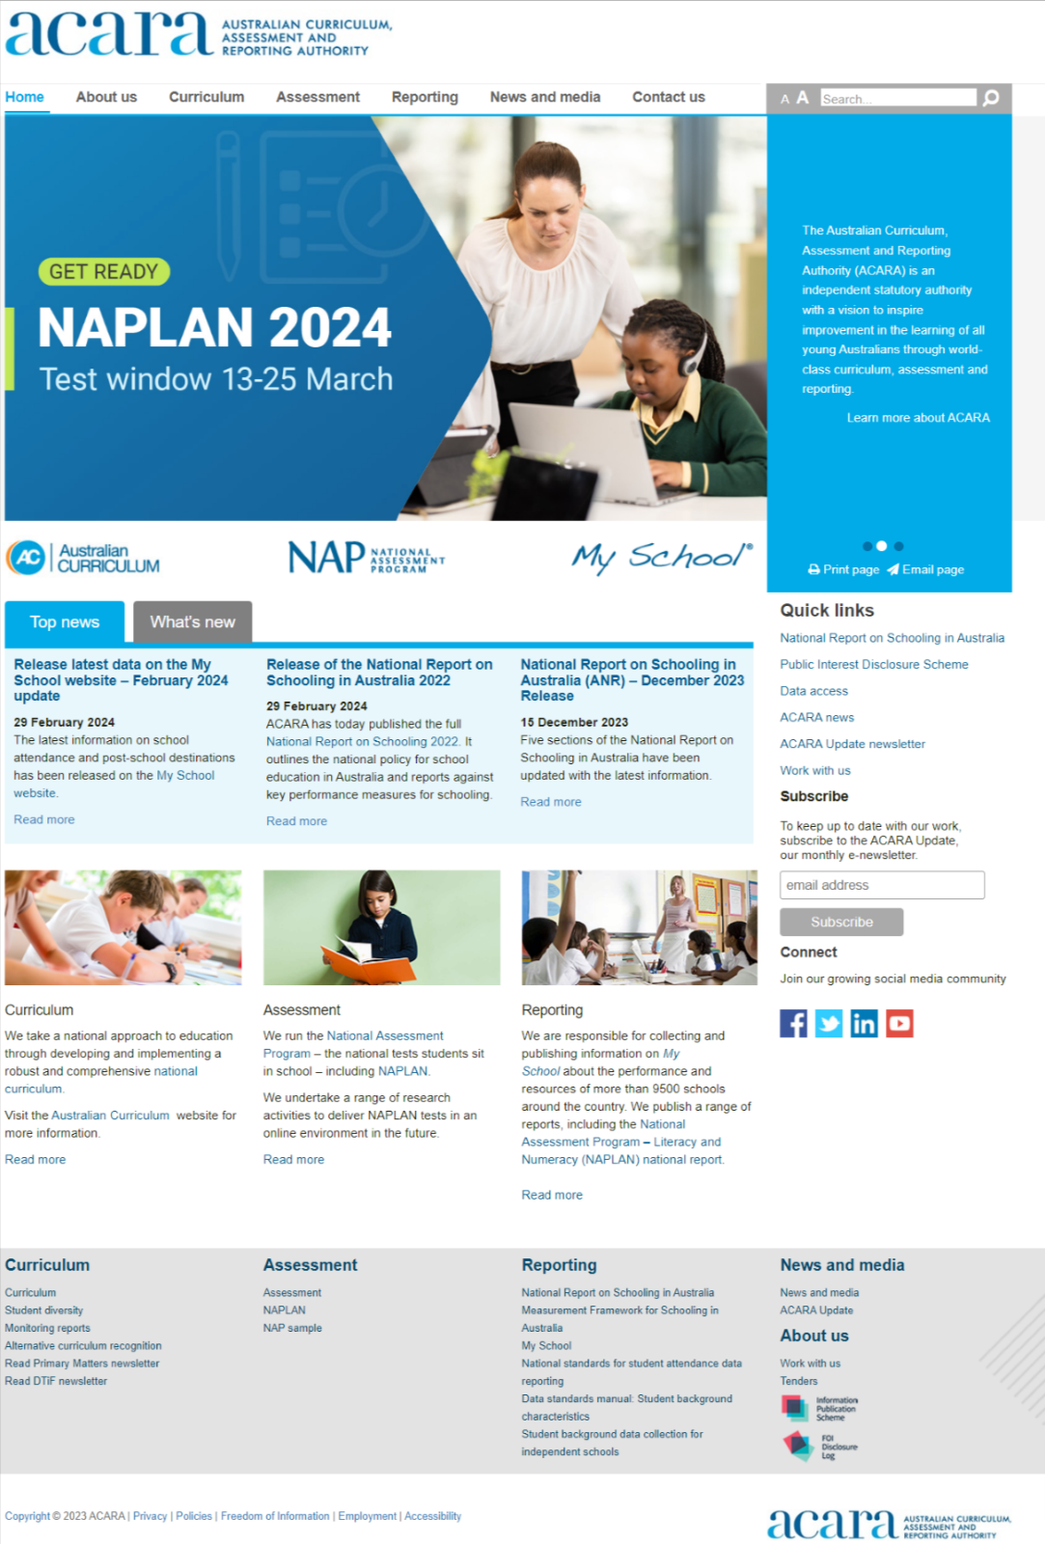

1.3.2 NAP website
The NAP website (https://www.nap.edu.au/) includes information on:
- the National Assessment Program - Literacy and Numeracy (NAPLAN)
- NAP sample assessments in
- science literacy
- civics and citizenship
- information and communication technology (ICT) literacy
- NAP opt-in assessments
- participation in international sample assessments.

NAPLAN is an annual assessment for all students in Years 3, 5, 7 and 9. It tests skills in reading, writing, spelling, grammar and punctuation, and numeracy.

There is some overlap in content between the ACARA and NAP websites. What’s more, to find what they need, users often need to go from one website to the other, and back again.

Like the ACARA website, the NAP website:
- uses the Sitefinity CMS and has similar issues with updating content
- can be difficult to navigate
- has pages which aren't written in plain language.

Content-wise, similar to the ACARA website, the NAP website mainly consists of the following content types:
- text, images and links on html pages
- documents (mainly pdf)
- embedded videos.

The NAP website tends to make more use of tables on HTML pages, some of which contain data e.g. NAPLAN score cut points on https://www.nap.edu.au/naplan/results-and-reports).

NAP website homepage.

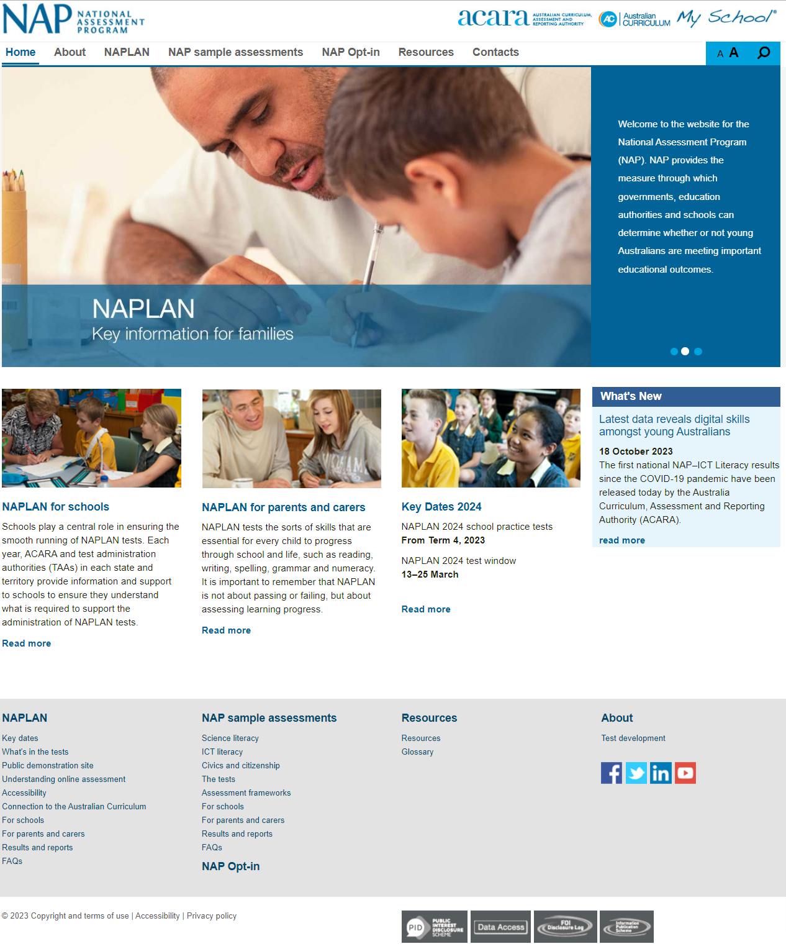

1.4 Specifications
The scope of this project will cover the following areas:
- Detailed design of the ACARA website
- Development of the ACARA website on the AEM platform
- Facilitation of strategic discussion to determine what lives where in ACARA’s digital ecosystem, including the potential amalgamation of the ACARA and NAP websites.
- If it’s decided the NAP website will be brought into the ACARA website
  - mapping NAP website content into the new ACARA website IA
- If it’s decided the NAP website will be built separately
  - detailed design of the NAP website
  - development for the NAP website on the AEM platform
- Configuration of the CMS central platform to house 2 or 3 websites
  - https://www.acara.edu.au
  - https://www.nap.edu.au
  - https://v9.australiancurriculum.edu.au
- Test management
- Deployment management of all channels to the schedule listed above
- Change Management support
- Post-Live support

Each aspect of this project is further detailed below, and tenderers are requested to address all aspects in their response.

1.5 Architectural and design principles

As part of its ICT strategy, ACARA relies on several high-level architectural and design principles to ensure that its business is supported by technology solutions that minimise complexity and cost of maintenance. These principles can be broadly defined as:

  - Preference for out-of-the-box solutions with minimal customisation and preference for configuration, sometimes at the expense of functionality.
  - Minimisation of customisation leading to reduction in cost of maintenance.
  - Minimisation of overall number of solutions sets and minimization of overlap in functionality of solutions sets to provide clear role and value proposition for each solution.

ACARA has high-level designs of templates and components for its new ACARA website. Please see Appendices.

1.6 Strategy Support

We want to understand how we best tell ACARA’s story through our digital ecosystem and how the ecosystem can better reflect the interconnectedness of ACARA’s work and the three key pillars: curriculum, assessment, and reporting.

As the Australian Curriculum website is a tool (it is the curriculum) it would continue as a separate channel. Some curriculum content e.g. monitoring reports will remain on the ACARA website.

It is envisaged My School will continue as a separate website (with ASL potentially incorporated into My School).

Currently, the ACARA website houses the reporting data in the form of an interactive data portal for the national report on schooling and static reports for previous years. A separate stream of work to improve the visualization and presentation of the national reporting data (currently housed on the ACARA corporate site) has been done as a short-term content improvement on the existing ACARA corporate website.

Current proposed options for the ACARA website and NAP website are as follows:

Option 1: NAP site content goes into the ACARA site.

Option 2: ACARA and NAP remain standalone channels – with increased and clearer editorial on both sites regarding the value they offer stakeholders.

1.7 Detailed design for NAP website (optional)

The Contractor will be required to work with ACARA’s internal business units to develop a set of detailed designs to demonstrate the look and feel, navigation and initial functionality of the new NAP website if we go down that path. A detailed business requirements document and component identification will also be an expected output of the detailed design phase.

1.8 Development and testing of the ACARA website

ACARA has chosen AEM as its new CMS platform. The Contractor will be required to build the ACARA and NAP websites (if it’s decided NAP will be a standalone website) on Adobe AEM, using templates and components from the existing library developed for v9.australiancurriculum.edu.au and building any new templates and components identified.

Expected functionality in AEM will include (but is not limited to):
- Content authoring and publishing
- User groups and permissions
- Approval workflows
- Digital Asset Management
- Experience and content fragments
- Tag management
- Search function – to find content in AEM
- Timeline – to see previous versions of pages and assets
- References – to see links to and from other pages and assets
- Embedding content using the embed component e.g. PowerBI content, forms, social media feeds
- SEO optimisations and site analytics (Adobe Analytics and Google Analytics) to track visits and usage
- Integration with Salesforce for enquiries and subscriptions
- ACARA/NAP website able to use V9 website templates and components and vice versa
- Mobile responsive – templates and components mobile responsive without need for author to change container settings
- Password protect a preview page – so ACARA, the Reporting team especially, can send out page previews for review
- Collection of on-page user feedback
- Ecosystem-wide site search – that allows users to search ACARA website, Curriculum (v9 and v8.4) websites, NAP website (if separate)
The external facing website must meet WCAG 2.1 AA requirements.

ACARA currently manages its development work in Azure DevOps and has experience in Agile delivery. The Contractor will be expected to manage code development in separate DEV, QA and UAT environments as per best practice.

As with any software development project, the development on AEM platform and any integrations will require rigorous testing, both during development and prior to deployment. The Contractor is expected to conduct all end-to-end testing for this project, in consultation with ACARA’s Senior Test Lead.

A detailed test plan and development of test cases against the final detailed requirements specification will be expected as well as accessibility, performance, and security testing. Testing would also include require regression testing by ACARA’s QA team. Depending on the nature of the update, data or frontend/UI, the regression suite will likely need to be run a few times during the year. It is expected that the successful contractor develops and handover a regression test suite and related documentation that the in-house ICT and business teams, can adopt, execute and maintain in future BAU mode.

Upon completion of the build ACARA will arrange for third-party penetration testing to be conducted. The Contractor is expected to manage and support User Acceptance Testing (UAT) with the business stakeholders.

1.9 Change Management

The Contractor will be required to partner with the project team to provide input to ACARA-led change management activities and deliverables. The focus will be on effectively engaging with internal and external stakeholders to get their input, build their support, and set the foundations for the successful usage and adoption of the new website(s) and AEM (CMS) platform.

In addition, the contractor will be required to lead:
- showcases to build awareness and desire to support the new website(s) and any associated changes to internal practices (people, process, and technology)
- the development and delivery of training sessions and support materials to ensure ACARA employees have the knowledge, skills and mindset needed to be proficient users of the CMS (AEM) platform (noting some training materials are available and were used as part of the implementation of the Australian Curriculum, Version 9.0 website).

1.10 Post Live Support / Handover

As part of transition to business-as-usual, the Contractor will be expected to provide support to the in-house development team with a view to ensuring knowledge transfer to our developers. This is expected to include documentation – as mentioned earlier: detailed design and information architecture documentation and diagrams. The handover process would likely also include some workshops with our in-house development team so they can understand the implemented solution. The contractor is also expected to add to the existing training material for the end users for new components and functionality.

1.11 Mandatory Criteria

1.21.1 The Respondent must be an organisation with at least 50 staff at the closing time of the REOI.

1.21.2 The Respondent must manage the project and relationship with ACARA from within Australia.

1.12 Statement of Requirements – Evaluation Criteria

1.22.1 A large diverse organisation, with expertise in designing and developing cost effective solutions with Adobe Experience Manager for public sector, small organisations.

1.22.2 The capability of the organisation to partner with ACARA to deliver a complex project across several years to design and implement an ecosystem to support our multi-channel audience led digital strategy.

1.13 Indicative timing
1.23.1 The Request for Tender is anticipated be released in May 2024, with the Build Project planned to commence in August 2024.
1.23.2 The above time frame is indicative only, noting paragraph 4.2.1 of this REOI.

Schedule 2 - EOI RESPONSE FORMS
Respondents should ensure that their EOIs include, as a minimum, each of the EOI Response Forms attached to this Schedule 2.

Attachment 1: Respondent's Details
Respondents should provide full responses in completing the following information to enable ACARA to clearly identify the entity responding to the REOI.
Full name of Respondent:

Trading or business name:

Respondent’s Contact who is authorised to represent and legally bind the Respondent (including name, address and other contact details):

If a company
The registered office:

The principal place of business:

The date and place of incorporation and the Australian Company Number:

Individual shareholders holding 20 per cent or more of any issued share capital:

Any related companies within the meaning of Section 50 of the Corporations Law:

If a trustee
Provide details of the relevant trust including a copy of the relevant trust deed (including any variations to that deed):

If a partnership
Provide details of the relevant partnership including a copy of the relevant partnership agreement:

Subcontractors
Please include a full explanation of any part of the services which the Respondent intends to subcontract to another entity, including the entity to which it intends to subcontract, the services the subcontractor would perform, any existing or past relationship between the subcontractor and any particular expertise or experience of the subcontractor.

Attachment 2: Respondent’s Deed
Respondents must complete the Respondent's Deed and include it in their EOI response.

DEED POLL
Date: ^insert date^
By: ^insert full legal name of Respondent^ (Respondent)

Context
Request for Expressions of Interest in relation to ^details^ (REOI).

Interpretation
In this Deed, terms not otherwise defined have the meaning ascribed to them in the REOI.

Compliance with REOI
The Respondent represents that it has read and understood, and that its EOI is submitted in accordance with, the REOI.

Offer
The Respondent undertakes that it will continue to participate in the REOI process in accordance with the REOI and on the basis of its EOI.
Where the EOI includes alternative proposals each feasible combination of alternatives shall be deemed a separate, valid Offer, and the succeeding provisions of this Deed apply accordingly.

Confidentiality
The Respondent will not, and will ensure that its employees, agents or subcontractors do not, either directly or indirectly record, divulge or communicate to any person any confidential information concerning the affairs of ACARA, the Commonwealth or a third party acquired or obtained in the course of preparing an EOI, or any documents, data or information provided by ACARA and which ACARA indicates to Respondents is confidential or which Respondents know or ought reasonably to know is confidential.
If the Respondent is a small or medium sized business, please state the number of hours the Respondent required to complete its response to this REOI: ^insert^

Ethical Dealing
The Respondent represents that its EOI has been compiled without the improper assistance of any current or former ACARA officer, employee, contractor or agent and without the use of information obtained unlawfully or in breach of an obligation of confidentiality to ACARA.
The Respondent represents that it has not:
        - engaged in misleading or deceptive conduct in relation to its EOI or the REOI process;
        - engaged in any collusive Tendering, anti-competitive conduct, or any other unlawful or unethical conduct with any other Respondent, or any other person in connection with the preparation of their EOI or the REOI process;
        - attempted to solicit information from or influence improperly any current or former officer, employee, contractor or agent of ACARA, or violate any applicable laws or Commonwealth policies regarding the offering of inducements in connection with the REOI process; or
        - otherwise acted in an unethical or improper manner or contrary to any law.

Conflict of Interest
The Respondent represents that, having made all reasonable enquiries the following represents its only known actual or potential conflicts of interest in respect of the REOI, its EOI or the provision of the ^Goods/Services^:
^insert list or, where no conflict exists, write ‘none’^
The Respondent undertakes to advise ACARA in writing immediately upon becoming aware of any actual or potential conflicts of interest in respect of the REOI, its EOI or the provision of the ^Goods/Services^.

Employee entitlements
The Respondent represents that, having made all reasonable enquiries, as at the date of this declaration, it is not subject to any judicial decisions or any resulting order relating to employee entitlements (not including decisions under appeal) which claims have not been paid.

Compliance with Australian standards
The Respondent represents that it is able to meet any Australian standards applicable to the ^Goods/Services^.

Indigenous Procurement Policy

Workplace Gender Equality Requirements
The Respondent understands that it is obliged to indicate whether or not it is covered by the Workplace Gender Equality Act 2012 (Cth) (the WGE Act). The Respondent is covered by the WGE Act if it is a ‘relevant employer’, defined as being a non-public sector employer (including higher education institutions, trade unions and not-for-profit organisations) of 100 or more employees in Australia. For information about the coverage of the WGE Act, contact the Workplace Gender Equality ACARA on (02) 9432 7000.
Note: Respondents must choose one of the following:
        - The Respondent confirms that it is a relevant employer. The Respondent has attached a current letter of compliance as part of its response which indicates its compliance with the Workplace Gender Equality Act 2012.
OR
        - The Respondent confirms that it is a relevant employer. If selected as the preferred or successful Respondent, the Respondent will upon request from the ACARA provide a current letter of compliance prior to entering into any contract. The Respondent acknowledges that failure to provide a current letter of compliance when requested will result in it losing its status as the preferred or successful Respondent.
OR
        - The Respondent confirms that it is not a relevant employer.
EXECUTED AS A DEED POLL for the benefit of the Australian Curriculum Assessment and Reporting Authority
Dated this ^insert day^ of ^insert month^ 202^year^
SIGNED SEALED AND DELIVERED by ^insert name of Respondent^ by its duly authorised representative:  ^Name of signatory^ | )  )  ) | Signature
In the presence of:  ^Name of witness^ |  | Signature of witness

Attachment 3: Response against the Mandatory Criteria
Respondents must provide a brief response (maximum 100 words) to each of the two Mandatory Criteria at point 1.11.

Attachment 4: Response against Evaluation Criteria
Respondents should provide a full and detailed response to each of the two requirements at the Statement of Requirements at point 1.12.

Attachment 5: Indicative Cost
To assist with budgeting, Respondents should provide the indicative cost for this project. The Indicative Cost will not be used for evaluation purposes.

Please provide a cost estimate for three phases:
1. detailed design,
2. build, and
3. content design/launch for each of the following options -
Option 1: NAP site content goes into the ACARA site and is built as a combined website.

Option 2: ACARA and NAP remain standalone websites.

Appendices

Appendix 1: List of templates and links to high-level designs in PDF

- Home page
- Level 1 landing page
- Content page
- Content page (With PowerBI embed for Reporting team)
- News landing page
- News article page

Appendix 2: List of components and link to high-level designs

- Notification bar
- Header
- Footer
- Breadcrumbs
- Mega menu (desktop)
- Mega menu (mobile)
- Side navigation
- Search (sitewide)
- Jump links
- Alerts
- Last updated
- User feedback
- Table
- Download
- Filters
- Separator
- Buttons and navigation boxes
- Content tiles

High-level designs zip file: https://www.acara.edu.au/docs/default-source/tenders/acara-website-components.zip

Appendix 3: User journeys

User journeys zip file: https://www.acara.edu.au/docs/default-source/tenders/acara-website-user-journeys.zip

Appendix 4: New acara.edu.au IA

IA PDF: https://www.acara.edu.au/docs/default-source/tenders/acara-website-ia.pdf

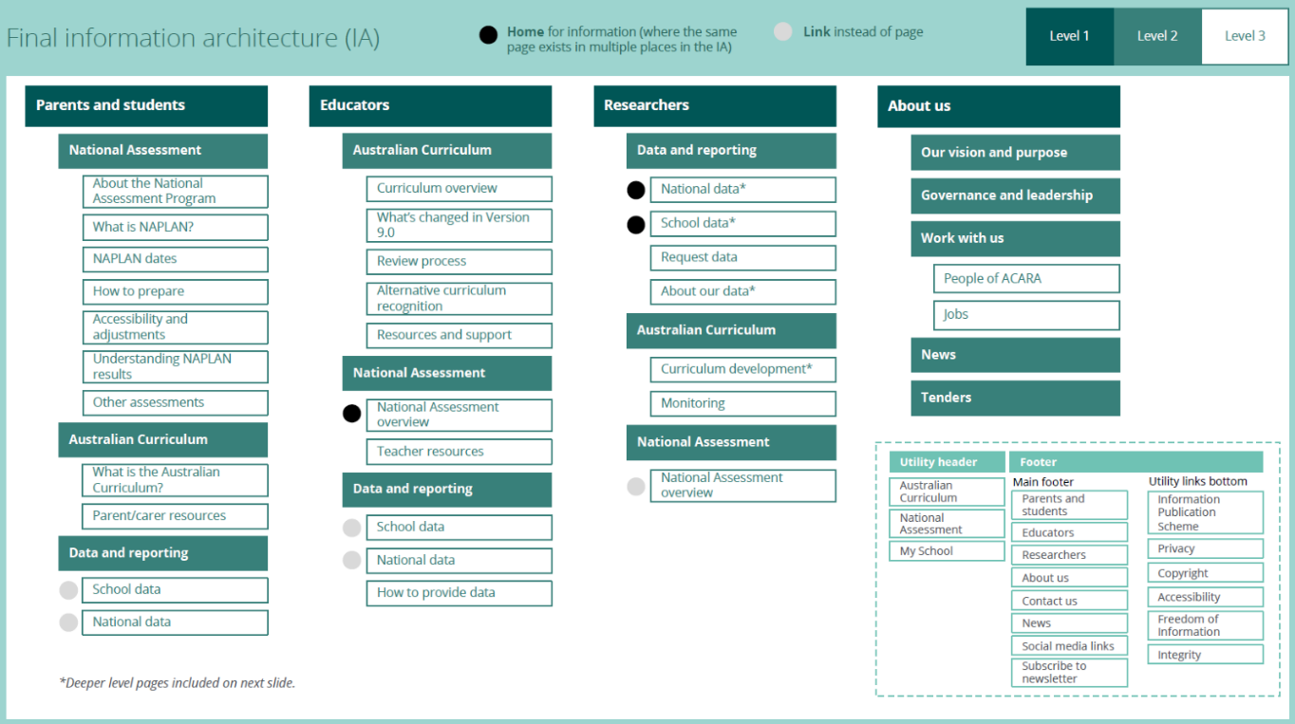
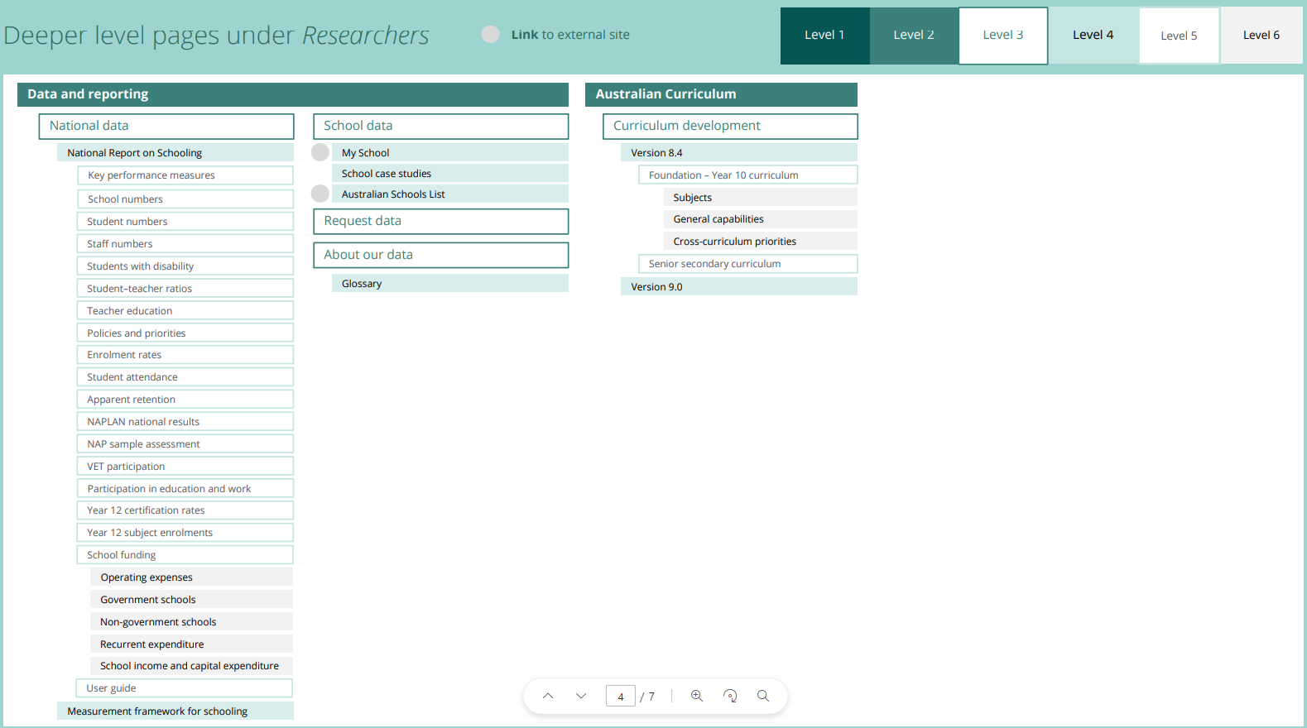

Appendix 5: ACARA Digital Vision

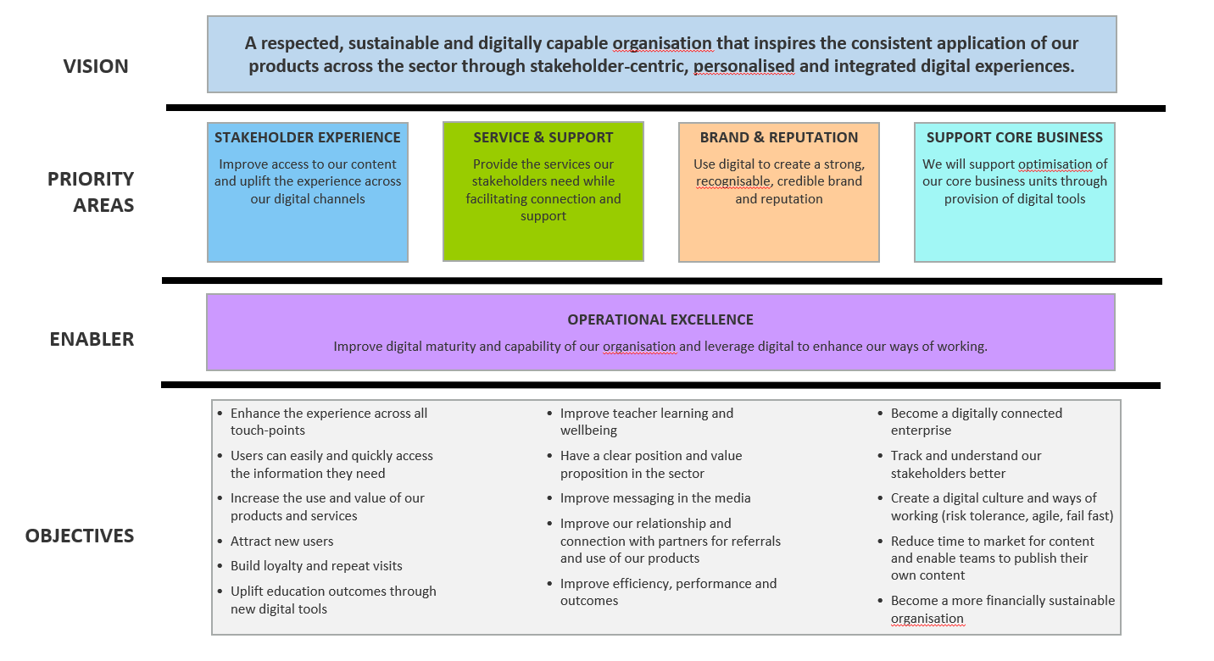

Appendix 6: Digital Channel Foundations program benefits

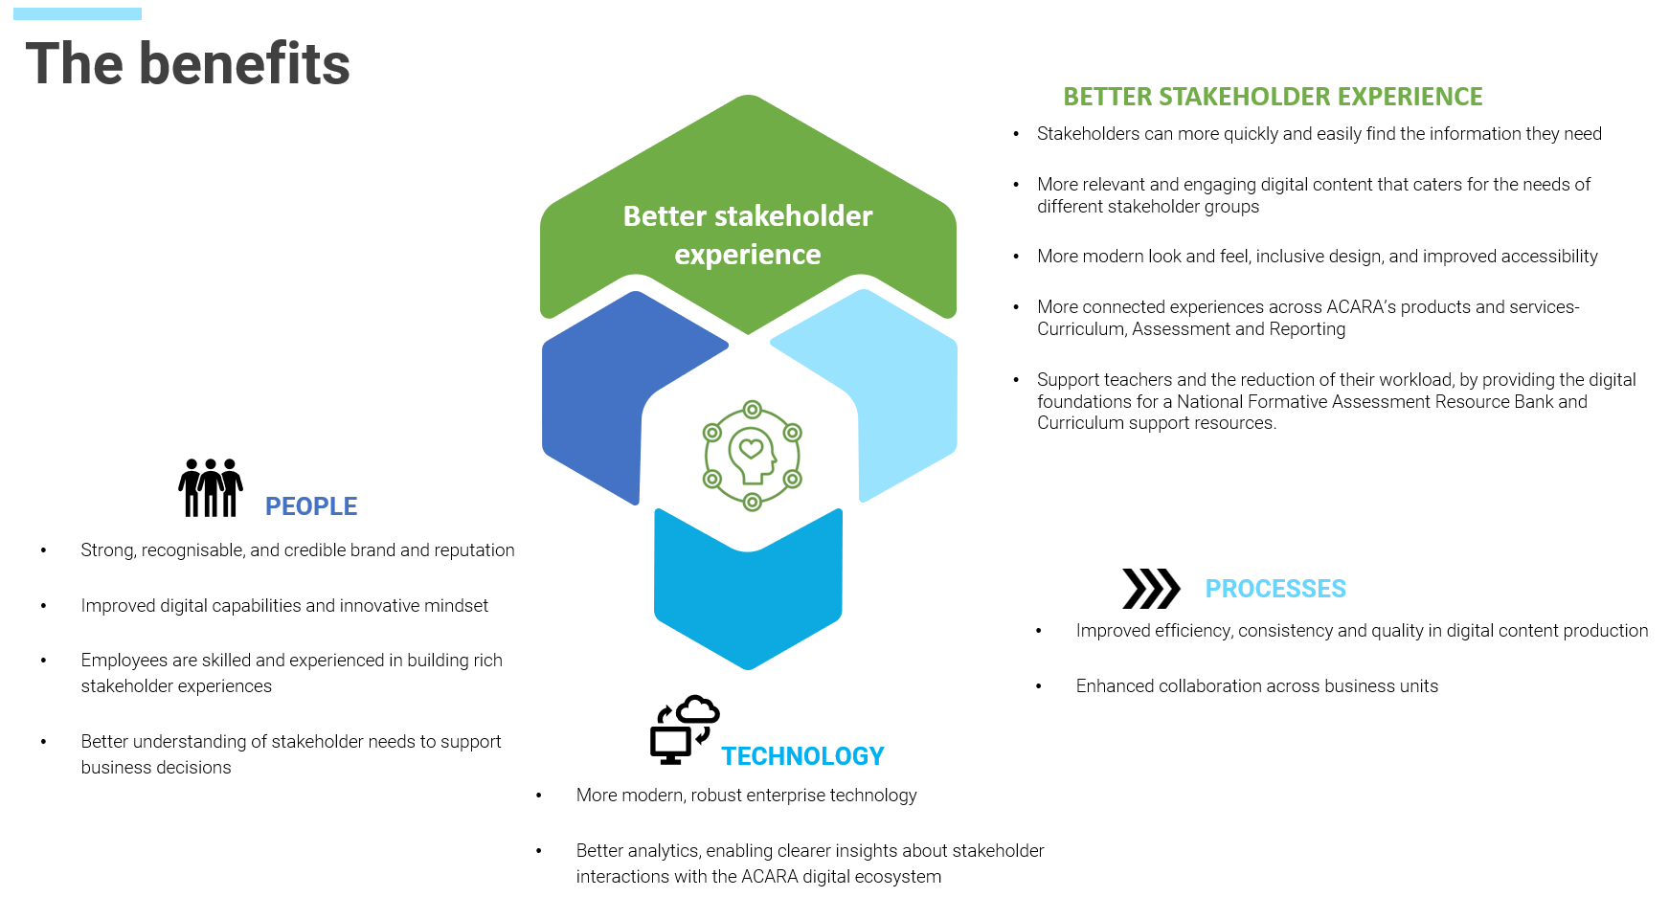

Appendix 7: ACARA Strategic Priorities

