Clarifications 1.

Request for tender – LMS
Reference | QUESTION | CLARIFICATION
1 | The RFT references alignment with the Australian Signals Directorate Information Security Guidelines. Could you please confirm whether ACARA expects formal mapping or certification against ASD/ISM controls, or whether demonstration of alignment via recognised frameworks (e.g. ISO 27001, SOC 2 Type II) and supporting narrative would be sufficient at the tender stage? | Demonstration of alignment and supporting narrative are all that are required at tender stage
2 | In relation to the on-shore data residency requirement, are there any specific expectations regarding offshore operational or support access to production environments, provided data is hosted within Australia? | ACARA will consider off-shore development and support activities; however, all Personally Identifiable Information (PII) and data must be hosted in Australia.
3 | The RFT specifies that all user data must be housed on-shore in Australia. Could you please confirm whether this requirement also applies to encrypted backups and disaster recovery environments, or whether these may be hosted outside Australia with appropriate safeguards in place? | ACARA’s requirement is that disaster recovery and back-ups are also housed on-shore in Australia.  For encrypted back-ups. ACARA’s preference is also for on-shore in the first instance, however, ACARA could consider off-shore hosting provided evidence of security safeguards and audits were provided.
4 | The requirements list a survey or feedback mechanism at the end of a course as “Required”. Would ACARA consider solutions where feedback is captured via integrated third-party tools (e.g. embedded forms or SCORM-based survey modules), or is a fully native LMS capability expected? | ACARA will consider all feedback mechanisms; however, feedback mechanisms within the LMS would be preferred.
5 | We note the requirement for SSO integration with Azure AD B2C and the planned introduction of a new login feature on the Australian Curriculum website around June 2026. To help us understand the expected implementation approach, could you please confirm:  • Whether Azure AD B2C is already in place or still under implementation  • Whether user provisioning is expected to occur via SSO (e.g. JIT provisioning) or whether batch/API-based provisioning would also be acceptable  • Whether any preliminary technical documentation or architecture guidance is available for tenderers to review | Development of our log-in solution via Azure B2C is currently under development.  Support for bulk user provisioning via User Interface (UI) or API integration or Just-In-Time (JIT) provisioning is highly preferred.  Solution design documentation for Log-in SSO can be provided to the successful tenderer as part of project commencement for the LMS development.
6 | The RFT references the ability to render Arabic script and other special characters. Could you confirm whether this relates specifically to content rendering within courses, or whether user interface localisation (e.g. full RTL language support) is also anticipated? | The requirement for rendering various language scripts and special characters relates only to the presentation of course content in those languages – see for example, the content in the Arabic curriculum where the Elaborations provide some content written in Arabic script,  https://www.australiancurriculum.edu.au/f-10-curriculum/learning-areas/arabic-f-10-sequence/year-2?view=quick&detailed-content-descriptions=1&hide-ccp=0&hide-gc=0&side-by-side=1&strands-start-index=0  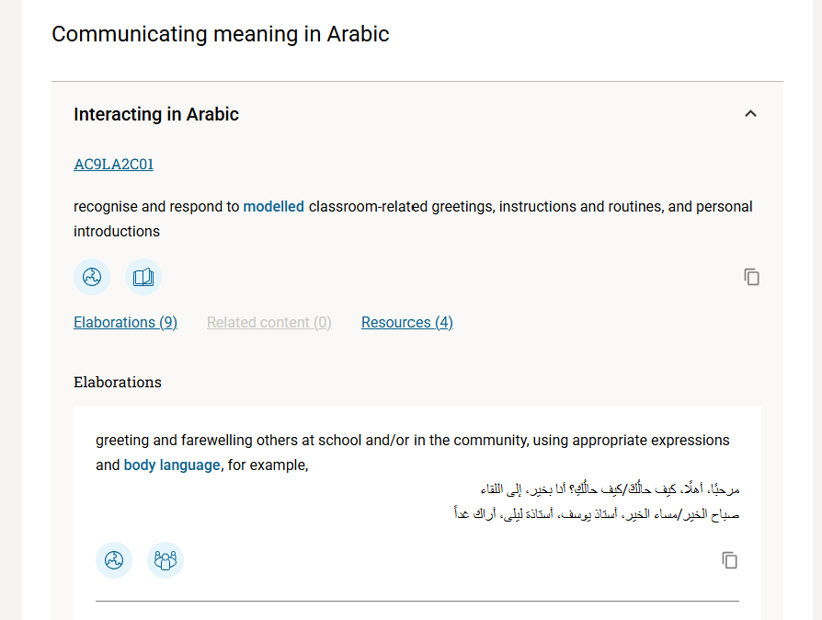  ACARA does not expect to provide the LMS experience in other languages for users to navigate or interact with the CMS in.
7 | For certificates upon course completion (listed as “Should have”), is branding with ACARA and Australian Curriculum logos sufficient, or is full template-level customisation of certificate layouts expected? | ACARA is happy to consider certificates with ACARA and Australian Curriculum logos included as a minimum.
8 | Requirement 2.3: Single sign on integration capability with Microsoft Azure B2C to enable seamless sign-in between the main Australian Curriculum website and the PL Hub  Clarification: Given Microsoft’s announcement that Azure AD B2C will end sales from 1 May 2025 and is being succeeded by Microsoft Entra External ID(https://learn.microsoft.com/en-us/azure/active-directory-b2c/faq?tabs=app-reg-ga#azure-ad-b2c-end-o…), could you please clarify the below?  - Which external identity/SSO platform does ACARA use (Azure AD B2C, Microsoft Entra External ID, or another identity provider?)  - If Azure AD B2C is currently in use, do you intend to transition to Entra External ID, and should vendors design for this future state?  - Are there specific identity standards (e.g., OIDC, OAuth 2.0, SAML) that ACARA requires solutions to support? | Currently, we use Azure AD B2C and in the future we'll be migrating to Microsoft Entra External ID when this product available in our region.  Yes. We need vendor assistance to migrate to Microsoft External Entra ID  No Need to support all identity standards, including OpenID Connect (OIDC), OAuth 2.0, and SAML 2.0.
9 | Requirement 2.9: Authoring tools: Ability to edit videos within the CMS (currently managed in separate, third-party video editing software prior to uploading to existing LMS)  Clarification: What is the expected level of video editing required, are you expecting to edit videos in situ. | We use Adobe Dynamic Media for primarily for video streaming and rich media delivery across our digital platforms.  In particular, we rely on it to:  Stream videos using adaptive bitrate delivery, ensuring optimal playback quality across different devices and network conditions.  Add and manage closed captions (e.g., VTT files) to support accessibility standards and multilingual audiences.  Generate automatic thumbnail images from video assets for use in previews, listings, and promotional placements.  Manage video renditions and encoding profiles, allowing us to deliver the appropriate format and resolution based on user context.  Centralise video asset management, including metadata, publishing workflows, and controlled distribution.
10 | Is the expectation that each user logs into the platform regularly over a 12-month period or will they only log in a handful of times throughout the year for sessions lasting a few hours / days? | Users should be logging in regularly to use the system. Session expiry will be in place.
11 | This website address –  (http://www.acara.edu.au/tenders/tenders/html).  to access RFT documentation on page 3, section 3.1.2 doesn’t work. | Apologies, the correct website is https://www.acara.edu.au/about-us/tenders

