February 2021

2021 Independent student background data submission guide
Contents
How to submit your student background data 3
Step 1 – Accessing the template 4
Step 2 – Extracting data and incorporating it into the template 5
Step 3 – Requesting an FTP account 6
Step 4 – Uploading data 7
Step 5 – Confirmation email from ACARA 8

How to submit your student background data
To submit your 2021 data, please follow the 5 steps below. Details on each step can be accessed via the hyperlinks.
Step 1 - Download the 2021 template (also available on the SBD site)
Step 2 - Extract student data from your system/database into the template
Step 3 - Request an FTP account
Step 4 - Upload your school/s completed spreadsheet to ACARA’s secure FTP site
Step 5 - Check the confirmation email from ACARA detailing if your data has been accepted.

Step 1 – Accessing the template
Visit https://www.acara.edu.au/reporting/student-background-data-collection-for-independent-schools and download the template.
There are 4 tabs within the spreadsheet;
- The 'Data dictionary' tab provides a description of all the data fields
- The 'SBD example' tab shows how your data should look within the template
- SBD Template is where your Student data needs to be entered
- The 'Language list' sheet contains the Australian Standard Classification of Languages to assist in entering values for the Students Main SLG (Spoken Language) and Parent Guardian 1/2 Main SLG spoken at home.

Step 2 – Extracting data and incorporating it into the template
- Extract Student data from your system.

- Completing the template
- Enter your data into the 'SBDTemplate' tab, ensuring;
  - Only one student is listed per row
  - An 'ACARA SML ID' and 'School name' is listed for all students as per the Australian Schools List site
  - The completed spreadsheet is renamed to “SBD_Independent_School_Template_2021 (your school name & ACARA SML ID)"
  - Column headers & tab names are not changed or renamed, as this will result in a data load error
  - If you are submitting the SBD data for multiple schools/campuses, please include ALL of them in one file
  - Submission of your file via the FTP site and NOT email. The reason we request this is because email attachments may not be secure.

Depending on your school/s software, you might be able to download data that aligns exactly with the template. Please double check it does before submitting.
Schools must ensure that the data provided in the template is valid according to the 'Data dictionary' tab of the template. For example, the parental school education entered must be a value of 0, 1, 2, 3 or 4.
Please ensure that the information entered is as complete and accurate as possible, as this data informs funding.

Step 3 – Requesting an FTP account
After clicking on the Request an FTP account enter your details into the form, ensuring the ACARA SML ID and School name provided match those on the Australian Schools List site.
You should receive your FTP instruction email shortly after requesting it. If you don’t, please check junk folders.
If you have any issues with the FTP creation, please email independentsbd@acara.edu.au.
The full link to the form is; https://www.acara.edu.au/reporting/student-background-data-collection-for-independent-schools/ftp-request-form

Step 4 – Uploading data
Once you’re logged into the ACARA secure FTP site, upload your file (ensuring you have renamed your file to include your school name and ACARA SML ID).

From there, you should be able to see your file in the folder
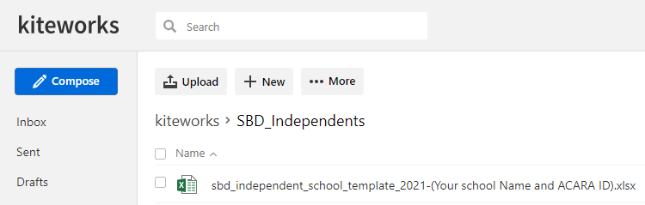

If you require assistance uploading your template, please contact independentsbd@acara.edu.au. Please do not email the template due to the sensitive nature of the information.

Step 5 – Confirmation email from ACARA
Once your template is received, automated quality control checks are completed by ACARA to ensure that the values provided in each column are valid for that field. If corrections are required to the data, an automated exception report will be emailed to you detailing what needs to be changed. If the data has passed all quality checks, a confirmation email will be sent to you.

