Graphical representation of NAPLAN ONLINE testlets for the different domains (Numeracy, Reading, Spelling and Grammar – Cross Test branching with Reading). One year is provided for each domain.
Numeracy
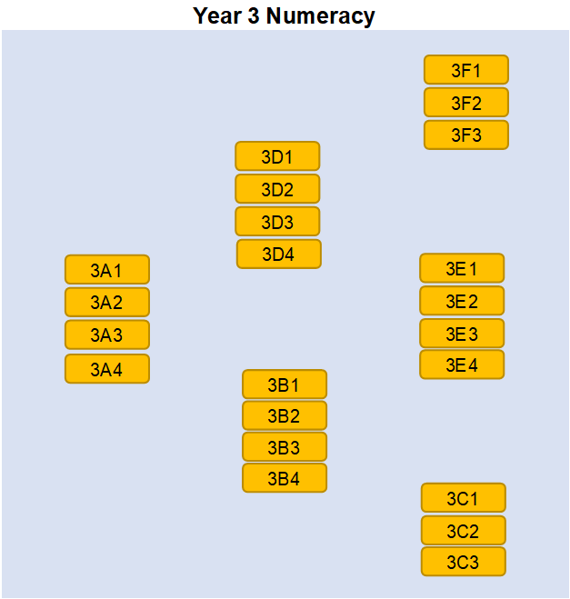

Reading
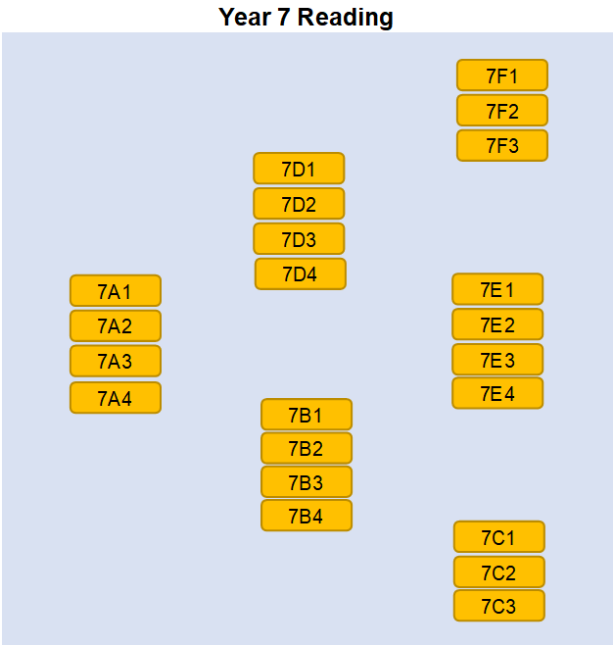
Spelling
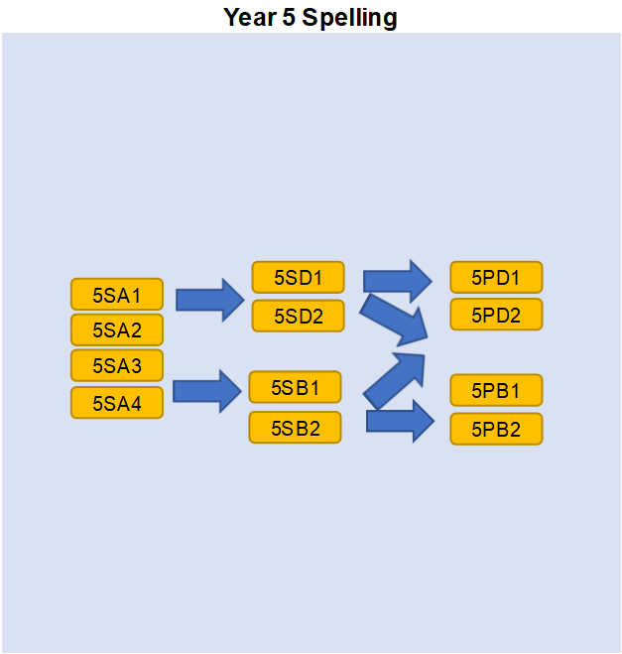
Grammar (Cross Test Branching with Reading)
