Appendix A: Online Adaptive Test Designs

1. Reading and Numeracy

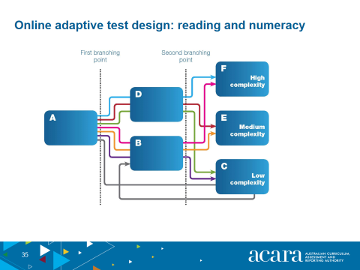

1. Grammar and Punctuation

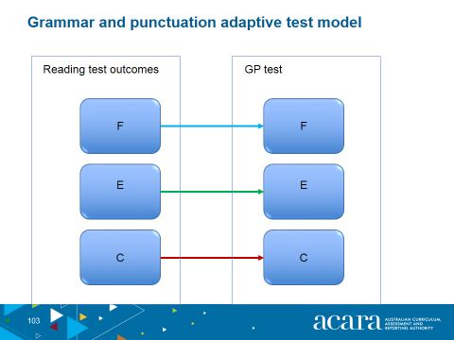

1. Spelling

