General Capabilities in the Australian Curriculum:
Work Studies, Year 9-10
The general capabilities play a significant role in the Australian Curriculum in equipping young Australians to live and work successfully in the twenty-first century.
In the Australian Curriculum, capability encompasses knowledge, skills, behaviours and dispositions. Students develop capability when they apply knowledge and skills confidently, effectively and appropriately in complex and changing circumstances, in their learning at school and in their lives outside school.
The Australian Curriculum includes seven general capabilities, as shown in the figure below.
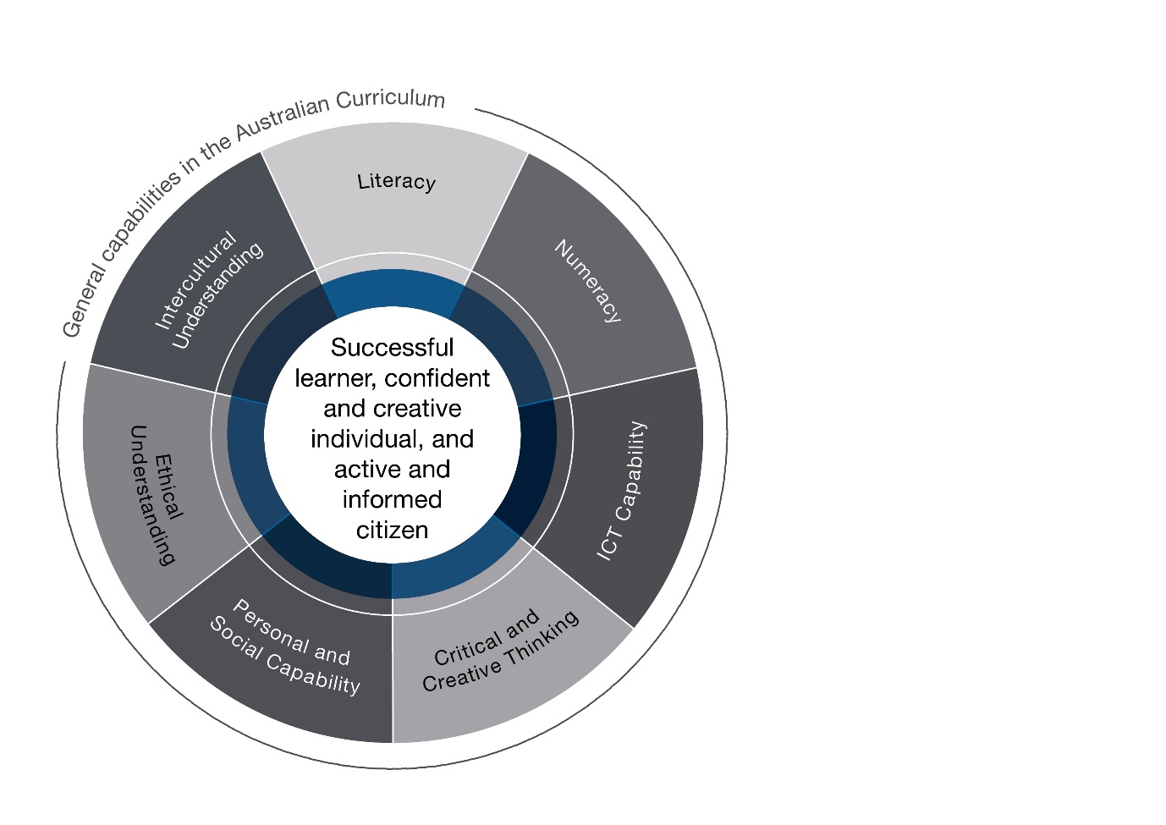

In the Australian Curriculum: Work Studies, Years 9-10, general capabilities are identified where they are developed or applied in the content descriptions. They are also identified where they offer opportunities to add depth and richness to student learning via the content elaborations, which are provided to give teachers ideas about how they might teach the content. Icons are used to indicate where general capabilities have been identified in learning area content descriptions and elaborations.

Literacy
In the Australian Curriculum: Work Studies, Years 9–10, students develop literacy capability as they adopt an appreciation of the skills of listening, speaking, reading, writing and interacting with others. They are given opportunities to locate and evaluate information, express ideas, thoughts and emotions, justify opinions, interact effectively with others, debrief and reflect and participate in a range of communication activities to support the development of literacy skills.
The development of critical workplace-related literacy skills is essential for students to become effective workforce participants who can access, interpret, analyse, challenge and evaluate the knowledge and skills required in a constantly growing and changing world of work.

Numeracy
In the Australian Curriculum: Work Studies, Years 9–10, students develop the knowledge and skills to use mathematics confidently across all learning areas at school, in the workplace and socially. This curriculum involves the use of mathematical knowledge, understanding and skills to achieve workplace and career development outcomes. Students strengthen their numeracy skills by making direct connections between their mathematical learning and the nature of mathematics required in workplaces and enterprises. They use numeracy in any situation that requires calculation and estimation, measurement, spatial understanding and design, the application and analysis of statistics and graphs and the identification of patterns, analysis of trends and making predictions based on these.
Students recognise that financial literacy is a requirement across enterprises and that numeracy helps them manage salaries and personal and workplace budgets and calculate personal and enterprise tax liabilities. They identify tasks that require numeracy and are able to select the skills, processes and tools, including digital technologies that are needed to complete tasks to the desired standard.

Information and Communication Technology (ICT) Capability
ICTs are key tools for communication, collaboration, content creation, seeking help, accessing knowledge and analysing performance in work and professional fields. In the Australian Curriculum: Work Studies, Years 9–10, students have opportunities to become competent, discriminating and creative users of ICT. Students learn how to access online career, employment and work information and services effectively and safely. They can use a range of ICT tools to analyse, measure and enhance their pathways after Years 9–10. Students develop an understanding of the breadth of communication, collaboration and content creation protocols and legalities related to online and mobile technologies. They learn different workplace strategies to minimise the risk of harm through the use of ICT.

Critical and Creative Thinking
In the Australian Curriculum: Work Studies, Years 9–10, students develop an ability to think logically, critically and creatively in relation to concepts of work and workplaces contexts. These capabilities are developed through an emphasis on critical thinking processes that encourage students to question assumptions and empower them to create their own understanding of work and personal and workplace learning.
Students’ creative thinking skills are developed and practised through learning opportunities that encourage innovative, entrepreneurial and project-based activities, supporting creative responses to workplace, professional and industrial problems. Students also learn to respond to strategic and problem-based challenges using creative thinking. For example, a student could evaluate possible job scenarios based on local labour market data and personal capabilities.

Personal and Social Capability
In the Australian Curriculum: Work Studies, Years 9–10, students work cooperatively with others in teams when undertaking project-based activities. Students develop interpersonal skills (such as communication, teamwork and leadership) and learn to appreciate the different strengths and abilities of themselves and their peers. Students are given opportunities to explore their own personal identity and develop an understanding of the influences that form their sense of identity.

Ethical understanding
In the Australian Curriculum: Work Studies, Years 9–10, students learn how ethical understanding focuses on the importance of treating others with honesty, integrity, consideration, compassion and respect. Students are given opportunities to explore moral principles and codes of practice appropriate to different contexts such as in building relationships at school, in the workplace and in the broader community, and to develop the commitment and capacity to be consistently guided by these principles.

Intercultural understanding
In the Australian Curriculum: Work Studies, Years 9–10, students are given opportunities to explore similarities and differences in cultural values, beliefs and practices in the context of work and enterprise and reflect on intercultural experiences. In doing so, students develop an understanding of the dynamic and variable nature of culture and its influence on people’s identities and ways of thinking, speaking and interacting. They appreciate the importance of negotiating and managing intercultural relations in the workplace in order to produce positive and shared outcomes. Students learn to recognise that their own cultural framework is not the only one and that cultural diversity brings great value to themselves, others, workplaces and their community.

