General Capabilities in the Australian Curriculum:
The Arts
The general capabilities play a significant role in the Australian Curriculum in equipping young Australians to live and work successfully in the twenty-first century.
In the Australian Curriculum, capability encompasses knowledge, skills, behaviours and dispositions. Students develop capability when they apply knowledge and skills confidently, effectively and appropriately in complex and changing circumstances, in their learning at school and in their lives outside school.
The Australian Curriculum includes seven general capabilities, as shown in the figure below.
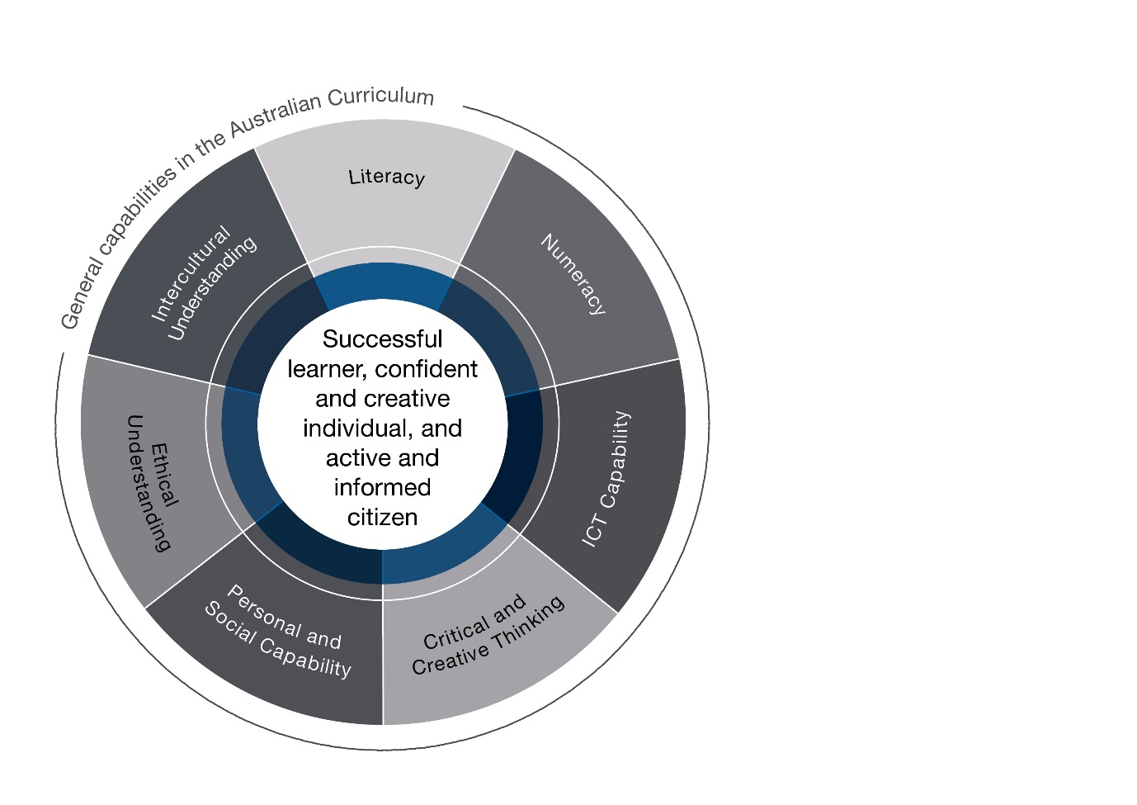

In the Australian Curriculum: The Arts, general capabilities are identified where they are developed or applied in the content descriptions. They are also identified where they offer opportunities to add depth and richness to student learning via the content elaborations, which are provided to give teachers ideas about how they might teach the content. Icons are used to indicate where general capabilities have been identified in learning area content descriptions and elaborations.

Literacy
In the Australian Curriculum: The Arts, students use literacy to develop, apply and communicate their knowledge and skills as artists and as audiences. Through making and responding, students enhance and extend their literacy skills as they create, compose, design, analyse, comprehend, discuss, interpret and evaluate their own and others’ artworks.
Each Arts subject requires students to learn and use specific terminology of increasing complexity as they move through the curriculum. Students understand that the terminologies of The Arts vary according to context and they develop their ability to use language dynamically and flexibly.

Numeracy
In the Australian Curriculum: The Arts, students select and use relevant numeracy knowledge and skills to plan, design, make, interpret, analyse and evaluate artworks. Across The Arts subjects, students recognise and use: number to calculate and estimate; spatial reasoning to solve problems involving space, patterns, symmetry, 2D shapes and 3D objects; scale and proportion to show and describe positions, pathways and movements; and measurement to explore length, area, volume, capacity, time, mass and angles. Students work with a range of numerical concepts to organise, analyse and create representations of data relevant to their own or others’ artworks, such as diagrams, charts, tables, graphs and motion capture.

Information and Communication Technology (ICT) Capability
In the Australian Curriculum: The Arts, ICT capability enables students to engage with digital and virtual technologies when making and responding to artworks. Students can, for example, use interactive multimedia platforms, communication and editing software, and virtual tools and environments, to design, create and share their artworks. Students learn to apply social and ethical protocols and practices in a digital environment, particularly in relation to the appropriate acknowledgment of intellectual property and the safeguarding of personal security when using ICT. They use digital technologies to locate, access, select and evaluate information, work collaboratively, share and exchange information, and communicate with a variety of audiences.

Critical and Creative Thinking
In the Australian Curriculum: The Arts, critical and creative thinking is integral to making and responding to artworks. In creating artworks, students draw on their curiosity, imagination and thinking skills to pose questions and explore ideas, spaces, materials and technologies. They consider possibilities and make choices that assist them to take risks and express their ideas, concepts, thoughts and feelings creatively. They consider and analyse the motivations, intentions and possible influencing factors and biases that may be evident in artworks they make to which they respond. They offer and receive effective feedback about past and present artworks and performances, and communicate and share their thinking, visualisation and innovations to a variety of audiences.

Personal and Social Capability
In the Australian Curriculum: The Arts, students identify and assess personal strengths, interests and challenges. As art makers, performers and audience, students develop and apply personal skills and dispositions such as self-discipline, goal setting and working independently, and show initiative, confidence, resilience and adaptability. They also learn to empathise with the emotions, needs and situations of others, to appreciate diverse perspectives, and to understand and negotiate different types of relationships. When working with others, students develop and practise social skills that assist them to communicate effectively, work collaboratively, make considered group decisions and show leadership.

Ethical understanding
In the Australian Curriculum: The Arts, students develop and apply ethical understanding when they encounter or create artworks that require ethical consideration, such as work that is controversial, involves a moral dilemma or presents a biased point of view. They explore how ethical principles affect the behaviour and judgement of artists involved in issues and events. Students apply the skills of reasoning, empathy and imagination, and consider and make judgements about actions and motives. They speculate on how life experiences affect and influence people’s decision-making and whether various positions held are reasonable.
Students develop their understanding of values and ethical principles when interpreting and evaluating artworks and their meaning. They consider the intellectual, moral and property rights of others. In particular, students learn about ethical and cultural protocols when engaging with Aboriginal and Torres Strait Islander Peoples and their histories, cultures and artistic practices.

Intercultural understanding
In the Australian Curriculum: The Arts, intercultural understanding enables students to explore the influence and impact of cultural identities and traditions on the practices and thinking of artists and audiences. Students develop and act with intercultural understanding in making artworks that explore their own cultural identities and those of others, interpreting and comparing their experiences and worlds, and seeking to represent increasingly complex relationships.
Students are encouraged to demonstrate empathy for others and open-mindedness to perspectives that differ from their own and to appreciate the diversity of cultures and contexts in which artists and audiences live. Through engaging with artworks from diverse cultural sources, students are challenged to consider accepted roles, images, objects, sounds, beliefs and practices in new ways.

