General Capabilities in the Australian Curriculum:
Science
The general capabilities play a significant role in the Australian Curriculum in equipping young Australians to live and work successfully in the twenty-first century.
In the Australian Curriculum, capability encompasses knowledge, skills, behaviours and dispositions. Students develop capability when they apply knowledge and skills confidently, effectively and appropriately in complex and changing circumstances, in their learning at school and in their lives outside school.
The Australian Curriculum includes seven general capabilities, as shown in the figure below.
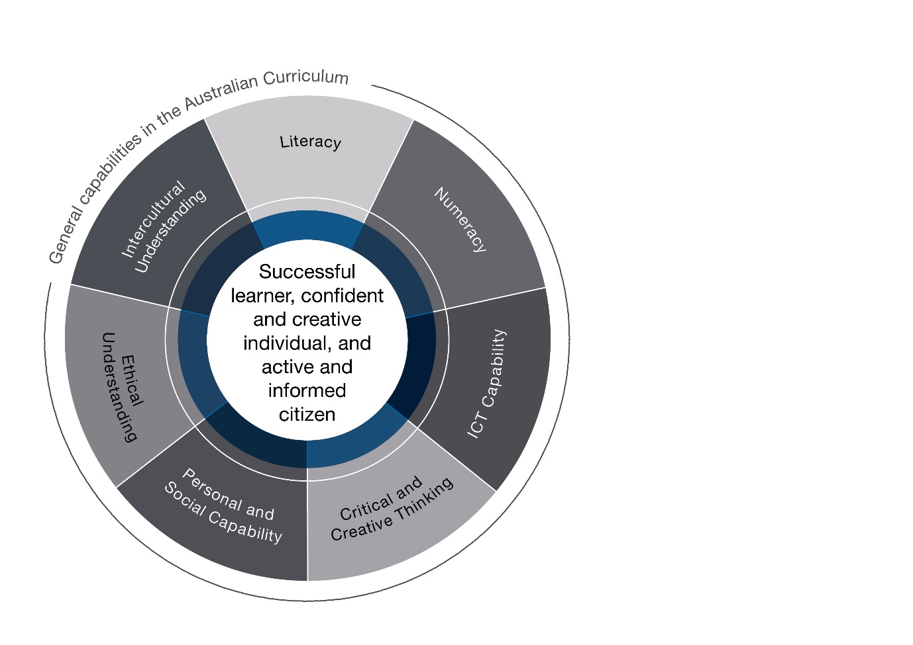

In the Australian Curriculum: Science, general capabilities are identified where they are developed or applied in the content descriptions. They are also identified where they offer opportunities to add depth and richness to student learning via the content elaborations, which are provided to give teachers ideas about how they might teach the content. Icons are used to indicate where general capabilities have been identified in learning area content descriptions and elaborations.

Literacy
In the Australian Curriculum: Science, students develop a broader literacy capability as they explore and investigate their world. They are required to comprehend and compose texts including those that provide information, describe events and phenomena, recount experiments, present and evaluate data, give explanations and present opinions or claims. They will also need to comprehend and compose multimedia texts such as charts, graphs, diagrams, pictures, maps, animations, models and visual media. Language structures are used to link information and ideas, give descriptions and explanations, formulate hypotheses and construct evidence-based arguments capable of expressing an informed position.
By learning the literacy of science, students understand that language varies according to context and they increase their ability to use language flexibly. Scientific vocabulary is often technical and includes specific terms for concepts and features of the world, as well as terms that encapsulate an entire process in a single word, such as ‘photosynthesis’. Language is therefore essential in providing the link between the concept itself and student understanding and for assessing whether the student has understood the concept.

Numeracy
Many elements of numeracy are evident in the Australian Curriculum: Science, particularly in Science Inquiry Skills. These include practical measurement and the collection, representation and interpretation of data
from investigations.
Students are introduced to measurement, first using informal units then formal units. Later, they consider issues of uncertainty and reliability in measurement. As students progress, they collect qualitative and quantitative data, which are analysed and represented in graphical forms. Students learn data analysis skills, including identifying trends and patterns from numerical data and graphs. In later years, numeracy demands include the statistical analysis of data, including issues relating to accuracy and validity, and the use of mathematical relationships to calculate and predict values and the use of mathematical tools to provide evidence in support of hypotheses
or positions.

Information and Communication Technology (ICT) Capability
In the Australian Curriculum: Science, students develop ICT capability when they research science concepts and applications, investigate scientific phenomena and communicate their scientific understandings. In particular, they use their ICT capability to access information; collect, analyse and represent data; model and interpret concepts and relationships; and communicate science ideas, processes and information.
Technology can be used to access information beyond our senses capability and to represent scientific phenomena in ways that improve students’ understanding of concepts, ideas and information. Digital aids such as animations and simulations provide opportunities to view phenomena and test predictions that cannot be investigated through practical experiments in the classroom and may enhance students’ understanding and engagement with science.

Critical and Creative Thinking
In the Australian Curriculum: Science, students develop capability in critical and creative thinking as they learn to generate and evaluate knowledge, ideas and possibilities, and use them when seeking new pathways or solutions. In the science learning area, critical and creative thinking are embedded in the skills of posing questions, making predictions, speculating, solving problems through investigation, making evidence-based decisions, and analysing and evaluating evidence. Students develop understandings of concepts through active inquiry that involves planning and selecting appropriate information, evaluating sources of information to formulate conclusions and to critically reflect on their own and the collective process.
Creative thinking enables the development of ideas that are new to the individual, and this is intrinsic to the development of scientific understanding. Scientific inquiry promotes critical and creative thinking by encouraging flexibility and open-mindedness as students speculate about their observations of the world and the ability to use and design new processes to achieve this. Students’ conceptual understanding becomes more sophisticated as they actively acquire an increasingly scientific view of their world and the ability to examine it from
new perspectives.

Personal and Social Capability
In the Australian Curriculum: Science, students develop personal and social capability as they engage in science inquiry, learn how scientific knowledge informs and is applied in their daily lives, and explore how scientific debate provides a means of contributing to their communities. This includes developing skills in communication, initiative taking, goal setting, interacting with others and decision-making, and the capacity to work independently and collaboratively.
The Science learning area enhances personal and social capability by expanding students’ capacity to question, solve problems, explore and display curiosity. Students use their scientific knowledge to make informed choices about issues that impact their lives such as health and nutrition and environmental change, and consider the application of science to meet a range of personal and social needs.

Ethical understanding
In the Australian Curriculum: Science, students develop the capacity to form and make ethical judgements in relation to experimental science, codes of practice, and the use of scientific information and science applications. They explore what integrity means in science, and explore and apply ethical guidelines in their investigations. They consider the implications of their investigations on others, the environment and living organisms.
They use scientific information to evaluate claims and to inform ethical decisions about a range of social, environmental and personal issues, for example, land use or the treatment of animals.

Intercultural understanding
There are opportunities in the Australian Curriculum: Science for students to develop intercultural understanding. Students learn to appreciate the contribution that diverse cultural perspectives have made to the development, breadth and diversity of science knowledge and applications. They become aware that the raising of some debates within culturally diverse groups requires cultural sensitivity. They recognise that increasingly scientists work in culturally diverse teams and engage with culturally diverse communities to address issues of
international importance.

