General Capabilities in the Australian Curriculum:
Mathematics
The general capabilities play a significant role in the Australian Curriculum in equipping young Australians to live and work successfully in the twenty-first century.
In the Australian Curriculum, capability encompasses knowledge, skills, behaviours and dispositions. Students develop capability when they apply knowledge and skills confidently, effectively and appropriately in complex and changing circumstances, in their learning at school and in their lives outside school.
The Australian Curriculum includes seven general capabilities, as shown in the figure below.
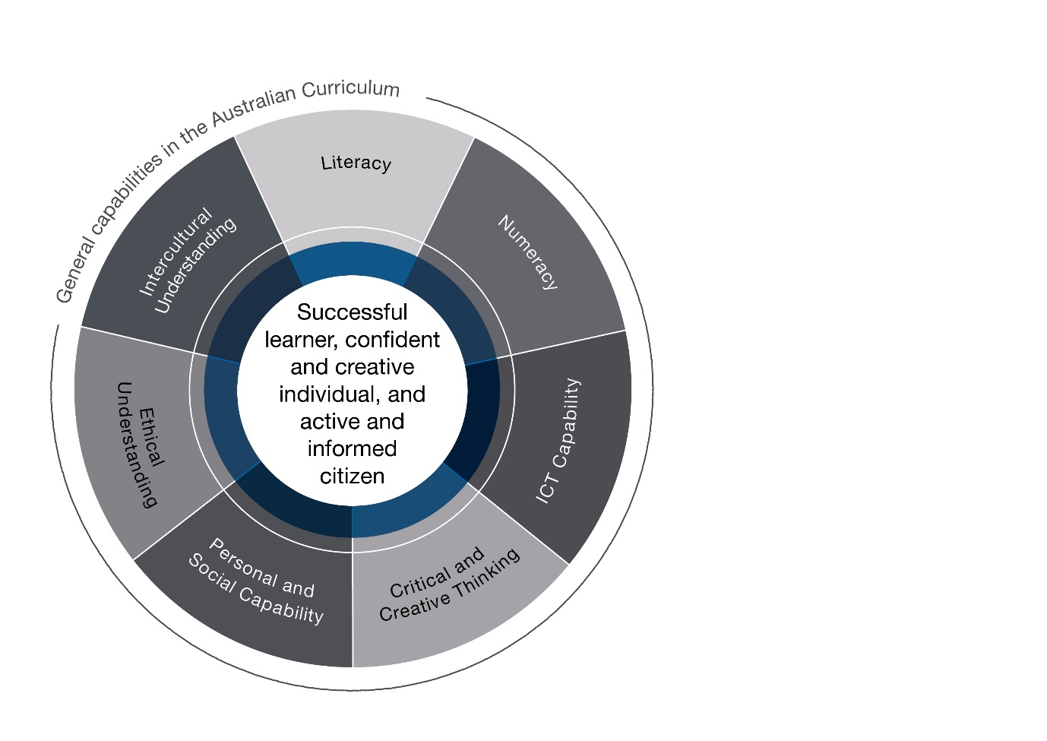

In the Australian Curriculum: Mathematics, general capabilities are identified where they are developed or applied in the content descriptions. They are also identified where they offer opportunities to add depth and richness to student learning via the content elaborations, which are provided to give teachers ideas about how they might teach the content. Icons are used to indicate where general capabilities have been identified in learning area content descriptions and elaborations.

Literacy
In the Australian Curriculum: Mathematics, students learn the vocabulary associated with number, space, measurement and mathematical concepts and processes. This vocabulary includes synonyms, technical terminology, passive voice and common words with specific meanings in a mathematical context. Students develop the ability to create and interpret a range of texts typical of mathematics ranging from calendars and maps to complex data displays. Students use literacy to understand and interpret word problems and instructions that contain the particular language features of mathematics. They use literacy to pose and answer questions, engage in mathematical problem-solving, and to discuss, produce and explain solutions.

Numeracy
The Australian Curriculum: Mathematics has a central role in the development of numeracy in a manner that is more explicit and foregrounded than is the case in other learning areas. It is important that the mathematics curriculum provides the opportunity to apply mathematical understanding and skills in context, in other learning areas and in real-world contexts. A particularly important context for the application of Number and Algebra is financial mathematics. In Measurement and Geometry, there is an opportunity to apply understanding to design. The twenty-first-century world is information driven, and through Statistics and Probability students can interpret data and make informed judgements about events involving chance.

Information and Communication Technology (ICT) Capability
In the Australian Curriculum: Mathematics, students develop ICT capability when they investigate, create and communicate mathematical ideas and concepts using fast, automated, interactive and multimodal technologies. They use their ICT capability to perform calculations; draw graphs; collect, manage, analyse and interpret data; share and exchange information and ideas; and investigate and model concepts and relationships.
Digital technologies, such as spreadsheets, dynamic geometry software and computer algebra software, can engage students and promote understanding of key concepts.

Critical and Creative Thinking
In the Australian Curriculum: Mathematics, students develop critical and creative thinking as they learn to generate and evaluate knowledge, ideas and possibilities, and use them when seeking solutions. Engaging students in reasoning and thinking about solutions to problems and the strategies needed to find these solutions are core parts of the Australian Curriculum: Mathematics.
Students are encouraged to be critical thinkers when justifying their choice of a calculation strategy or identifying relevant questions during a statistical investigation. They are encouraged to look for alternative ways to approach mathematical problems; for example, identifying when a problem is similar to a previous one, drawing diagrams or simplifying a problem to control some variables.

Personal and Social Capability
In the Australian Curriculum: Mathematics, students develop and use personal and social capability as they apply mathematical skills in a range of personal and social contexts. This may be through activities that relate learning to their own lives and communities, such as time management, budgeting and financial management, and understanding statistics in everyday contexts.
The Australian Curriculum: Mathematics enhances the development of students’ personal and social capabilities by providing opportunities for initiative taking, decision-making, communicating their processes and findings, and working independently and collaboratively in the mathematics classroom.

Ethical understanding
There are opportunities in the Australian Curriculum: Mathematics to explore, develop and apply ethical understanding in a range of contexts; for example, through analysing data and statistics; seeking intentional and accidental distortions; finding inappropriate comparisons and misleading scales when exploring the importance of fair comparison; and interrogating financial claims and sources.

Intercultural understanding
Intercultural understanding can be enhanced in the Australian Curriculum: Mathematics when students are exposed to a range of cultural traditions. Students learn to understand that mathematical expressions use universal symbols, while mathematical knowledge has its origin in many cultures. Students realise that proficiencies such as understanding, fluency, reasoning and problem-solving are not culture- or language-specific, but that mathematical reasoning and understanding can find different expression in different cultures and languages. New technologies and digital learning environments provide interactive contexts for exploring mathematical problems from a range of cultural perspectives and within diverse cultural contexts. Students can apply mathematical thinking to identify and resolve issues related to living with diversity.

