General Capabilities in the Australian Curriculum:
Languages
The general capabilities play a significant role in the Australian Curriculum in equipping young Australians to live and work successfully in the twenty-first century.
In the Australian Curriculum, capability encompasses knowledge, skills, behaviours and dispositions. Students develop capability when they apply knowledge and skills confidently, effectively and appropriately in complex and changing circumstances, in their learning at school and in their lives outside school.
The Australian Curriculum includes seven general capabilities, as shown in the figure below.
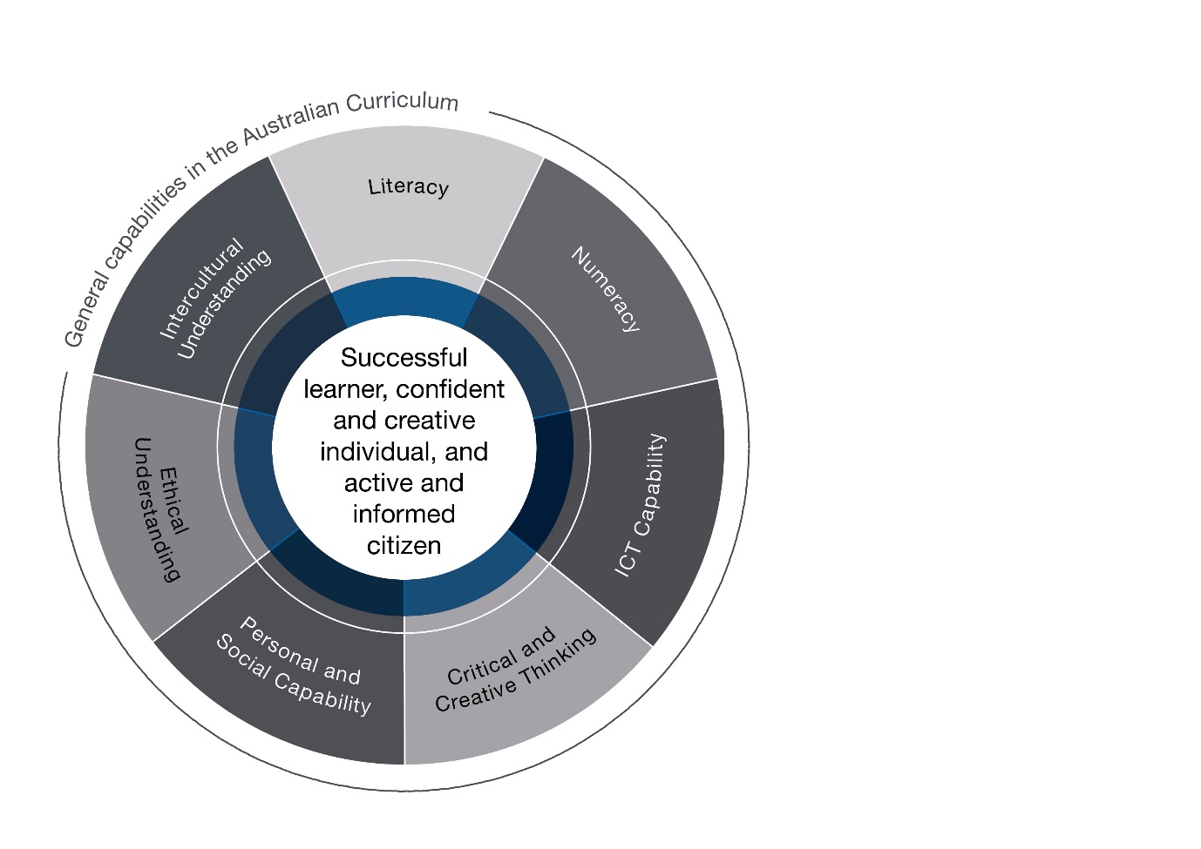

In the Australian Curriculum: Languages, general capabilities are identified where they are developed or applied in the content descriptions. They are also identified where they offer opportunities to add depth and richness to student learning via the content elaborations, which are provided to give teachers ideas about how they might teach the content. Icons are used to indicate where general capabilities have been identified in learning area content descriptions and elaborations.

Literacy
Learning in the Australian Curriculum: Languages develops overall literacy. It is in this sense ‘value added’, strengthening literacy-related capabilities that are transferable across languages, both the language being learnt and all other languages that are part of the learner’s repertoire. Languages learning also strengthens literacy-related capabilities across domains of use, such as the academic domain and the domains of home language use, and across learning areas.
Literacy development involves conscious attention and focused learning. It involves skills and knowledge that need guidance, time and support to develop. These skills include the ability to decode and encode from sound and written systems, the learning of grammatical, orthographic and textual conventions, and the development of semantic, pragmatic and interpretive, critical and reflective literacy skills.
Literacy development for second language learners is cognitively demanding. It involves these same elements but often without the powerful support of a surrounding oral culture and context. The strangeness of the additional language requires scaffolding. In the language classroom, analysis is prioritised alongside experience. Explicit, explanatory and exploratory talk around language and literacy is a core element. Learners are supported to develop their own meta–awareness, to be able to think and talk about how the language works and about how they learn to use it. Similarly, for first language learners, literacy development that extends to additional domains and contexts of use requires comparative analysis that extends literacy development in their first
language and English.

Numeracy
The Australian Curriculum: Languages affords opportunities for learners to use the target language to develop skills in numeracy, to understand, analyse, categorise, critically respond to and use mathematics in different contexts. This includes processes such as using and understanding patterns, order and relationships to reinforce concepts such as number, time or space in their own and in others’ cultural and linguistic systems.

Information and Communication Technology (ICT) Capability
Learning in the Australian Curriculum: Languages is enhanced through the use of multimodal resources, digital environments and technologies in the target language. Accessing live target language environments and texts via digital media contributes to the development of information and communication technology capabilities as well as linguistic and cultural knowledge. Accessing different real-time contexts extends the boundaries of the classroom.

Critical and Creative Thinking
Learning in the Australian Curriculum: Languages enables students to interact with people and ideas from diverse backgrounds and perspectives, which enhances critical thinking and reflection, and encourages creative, divergent and imaginative thinking. By learning to notice, connect, compare and analyse aspects of the target language, students develop critical, analytical and problem-solving skills.

Personal and Social Capability
In The Australian Curriculum: Languages students develop and use personal and social capability as they learn to interact and communicate effectively in an additional language with people of diverse language backgrounds. When students interpret and negotiate meaning in an additional language they also develop and demonstrate a range of personal skills - expressing their emotions appropriately, communicating with confidence and showing independence, resilience and adaptability when faced with unfamiliar situations.
Through exchanging ideas, opinions and experiences with others as part of language learning, students have explicit opportunities to develop social awareness and an appreciation of diverse perspectives. They learn to work collaboratively as they plan, negotiate, make decisions and take action together. Through opportunities to reflect on their learning experiences students develop a better understanding of themselves as language learners, helping to become effective communicators in an additional language and to engage appropriately with a range of social and cultural norms.

Ethical understanding
When learning another language through the Australian Curriculum: Languages, students are taught explicitly to acknowledge and value difference in their interactions with others and to develop respect for diverse ways of perceiving and acting in the world. Students have opportunities to monitor and adjust their own ethical points of view. In learning Aboriginal and Torres Strait Islander languages, students should consider appropriate ethical behaviour for engaging with the owners and custodians of the languages. Similar consideration is needed when interpreting and translating or when collecting and analysing primary research data.

Intercultural understanding
The development of intercultural understanding is a central aim of learning in the Australian Curriculum: Languages. It is integral to communicating in the context of diversity, the development of global citizenship and lifelong learning. Students bring to their learning various preconceptions, assumptions and orientations shaped by their existing language(s) culture(s) that can be challenged by the new language experience. Learning to move between the existing and new languages and cultures is integral to language learning and is the key to the development of students’ intercultural understanding. By learning a new language, or learning to use an existing language in new domains and contexts, students are able to notice, compare and reflect on things previously taken for granted; to explore their own linguistic, social and cultural practices as well as those associated with the target language. They begin to see the complexity, variability and sometimes the contradictions involved
in using language.
Learning a new language does not require forsaking the first language. It is an enriching and cumulative process, which broadens the learners’ communicative repertoire, providing additional resources for interpreting and making meaning. Learners come to realise that interactions between different people through the use of different languages also involves interactions between the different kinds of knowledge, understanding and values that are articulated through language(s) and culture(s). They realise that successful intercultural communication is not only determined by what they do or say, but also by what members of the other language and culture understand from what they say or do.

