General Capabilities in the Australian Curriculum:
Humanities and Social Sciences
The general capabilities play a significant role in the Australian Curriculum in equipping young Australians to live and work successfully in the twenty-first century.
In the Australian Curriculum, capability encompasses knowledge, skills, behaviours and dispositions. Students develop capability when they apply knowledge and skills confidently, effectively and appropriately in complex and changing circumstances, in their learning at school and in their lives outside school.
The Australian Curriculum includes seven general capabilities, as shown in the figure below.
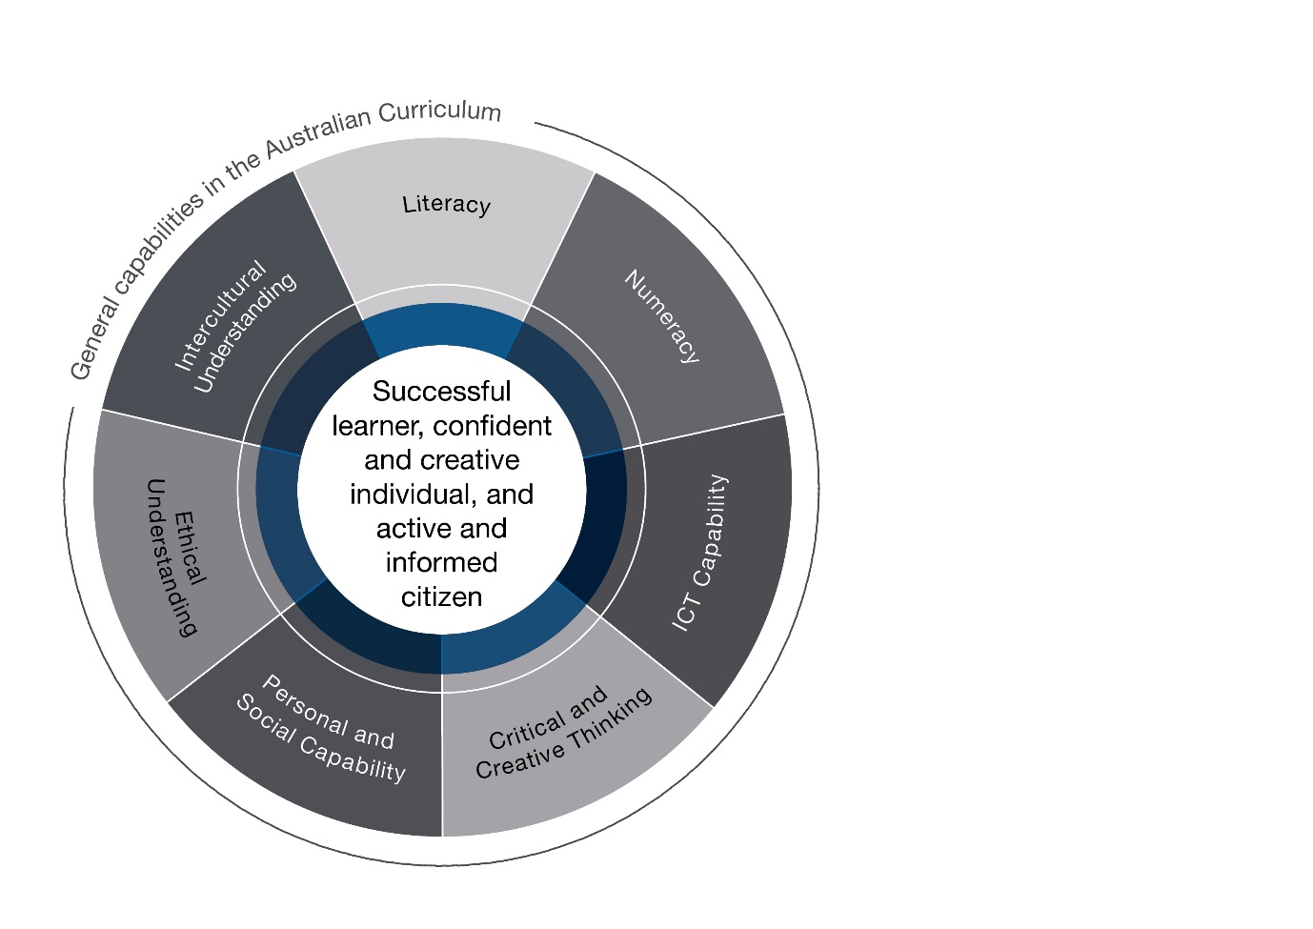

In the Australian Curriculum: Humanities and Social Sciences, general capabilities are identified where they are developed or applied in the content descriptions. They are also identified where they offer opportunities to add depth and richness to student learning via the content elaborations, which are provided to give teachers ideas about how they might teach the content. Icons are used to indicate where general capabilities have been identified in learning area content descriptions and elaborations.

Literacy
In the Australian Curriculum: Humanities and Social Sciences, students develop literacy capability as they learn how to build knowledge in relation to historical, geographical, civic and economic information, concepts and ideas. Students progressively learn to use a wide range of informational, persuasive and imaginative texts in multiple modes. These texts include stories, narrative recounts, reports, explanations, arguments, debates, timelines, maps, tables, graphs, images, often supported by references from primary and secondary sources.
Students learn to make increasingly sophisticated language and text choices, understanding that language varies according to context, including the nature and stages of their inquiry. They learn to use language features and text structures to comprehend and compose cohesive texts about places, people, events, processes, systems and perspectives of the past, present and future. These include topic-specific vocabulary; appropriate tense verbs; and complex sentences that describe sequential, cause-and-effect and comparative relationships. They recognise how language and images can be used to make and manipulate meaning and evaluate texts for shades of meaning and opinion. Students also participate in debates and discussions, and develop a considered point of view when communicating conclusions and preferred social and environmental futures to a range of audiences.

Numeracy
In the Australian Curriculum: Humanities and Social Sciences, students develop numeracy capability as they apply numeracy skills in relation to historical, geographical, civic and economic inquiries. Students count and measure data and information, construct and interpret tables and graphs, and calculate and interpret statistics in their investigations. Students learn to use scaled timelines, including those involving negative and positive numbers, as well as calendars and dates, to recall information on topics of historical significance and to illustrate the passing of time. They collect data through methods such as surveys and field tests, and construct and interpret maps, models, diagrams and remotely sensed and satellite images, working with numerical concepts of grids, scale, distance, area and projections.
Students learn to analyse numerical data to make meaning of the past; to test relationships in patterns and between variables, such as the effects of location and distance; and to draw conclusions. They make predictions and forecast outcomes based on civic, economic and business data and environmental and historical information and represent their findings in numerical and graphical form. Students use numeracy to understand the principles of financial management, and to make informed financial and business decisions. They appreciate the ways numeracy knowledge and skills are used in society and apply these to hypothetical and/or real-life experiences.

Information and Communication Technology (ICT) Capability
In the Australian Curriculum: Humanities and Social Sciences, students develop ICT capability when they locate, process, analyse, evaluate and communicate historical, geographic, civic and economic information using digital technologies. Students access and use digital technologies, including spatial technologies, as an investigative and creative tool. They seek a range of digital sources of information to resolve inquiry questions or challenges of historical, geographic, civic and economic relevance, being aware of intellectual property. They critically analyse evidence and trends and critique source reliability. Using digital technologies, students present and represent their learning; and collaborate, discuss and debate to co-construct their knowledge. They plan, organise, create, display and communicate data and information digitally using multimodal elements for a variety of reasons
and audiences.
Students enhance their understanding of ICT by exploring the increasing use of technology and the effects of technologies on people, places and civic and economic activity over time and place. They learn about and have opportunities to use social media to collaborate, communicate, and share information, and build consensus on issues of social, civic, economic and environmental significance, whilst using an awareness of personal security protocols and ethical responsibilities.

Critical and Creative Thinking
In the Australian Curriculum: Humanities and Social Sciences, students develop critical and creative thinking as they investigate historical, geographic, civic and economic concepts and ideas through inquiry-based learning. Students develop critical thinking by learning to develop and clarify investigative questions, and to question sources and assess reliability when selecting information from sources. Students learn discipline-specific ways of thinking, including interpreting the past from incomplete documentation, developing an argument using evidence, interpreting and analysing economic data and/or information, and systems thinking to inform predictions and propose solutions. They learn to think logically when evaluating and using evidence, testing explanations, analysing arguments and making decisions, and when thinking deeply about questions that do not have straightforward answers.
Students learn the value and process of developing creative questions and the importance of speculation. They apply concepts and skills to new contexts and learn to develop new interpretations to explain aspects of the past and present that are contested or not well understood. They are encouraged to be curious and imaginative in investigations and fieldwork, and to consider multiple perspectives about issues and events. They imagine alternative futures in response to social, environmental, civic and economic challenges that require problem solving and innovative solutions, proposing appropriate and alternative courses of action and considering the effects on their own lives and the lives of others. In so doing, students develop enterprising behaviours and capabilities and learn to apply decision-making processes including negotiation and conflict-resolution.

Personal and Social Capability
In the Australian Curriculum: Humanities and Social Sciences, students’ personal and social capability is enhanced as they gain understanding about people, places, processes and phenomena. Through historical, geographic, civic and economic inquiry, collaboration and reflective practice, students develop an appreciation of the insights and perspectives of others, past and present; and an understanding of what informs their personal identity and sense of belonging, including place and their cultural and national heritage. Inquiry-based learning assists students to develop their capacity for self-management, directing their own learning and providing opportunities to express and reflect on their opinions, beliefs, values and questions appropriately.
As students work independently and collaboratively, they are encouraged to develop personal and interpersonal skills, behaviours and dispositions that enable communication, empathy, teamwork, negotiation and conflict resolution to maintain positive relationships. They learn and apply enterprising behaviours and capabilities such as leadership, resilience, goal-setting and advocacy skills and informed, responsible decision-making. In turn, students develop the capacity to achieve desired outcomes peacefully and to make a contribution to their communities and society more broadly.

Ethical understanding
In the Australian Curriculum: Humanities and Social Sciences, students’ capacity for ethical understanding is enhanced by the unique contexts offered through historical, geographical, civic and economic inquiry. Students investigate the ways that diverse values and principles have influenced human activity and recognise that examining the nature of evidence deepens their understanding of ethical issues. Students learn about ethical procedures for investigating and working with people and places, including with Aboriginal and Torres Strait Islander Peoples. Students critically explore ethical behaviour of people of different times and places that may be the result of differing standards and expectations and changing societal attitudes. They evaluate their findings about consumer choices, and about current geographical issues against the criteria of environmental protection, economic prosperity and social advancement, raising ethical questions about human rights and citizenship. Students discuss and apply ethical concepts such as equality, respect and fairness, and examine shared beliefs and values which support Australian democracy and citizenship.
As students develop informed, ethical values and attitudes as they explore different perspectives, ambiguities and ethical considerations related to social and environmental issues, they become aware of their own roles, rights and responsibilities as participants in their social, economic and natural world. They consider the consequences of personal and civic decisions, for individuals, society and other forms of life that
share the environment.

Intercultural understanding
In the Australian Curriculum: Humanities and Social Sciences, students develop intercultural understanding as they learn about the diversity of the world’s places, peoples and their lives, cultural practices, values, beliefs and ways of knowing. Students learn the importance of understanding their own and others' histories, recognising the significance of Aboriginal and Torres Strait Islander peoples’ histories and cultures and the contribution of Australian migrants. They have opportunities to learn about the historic benefits and challenges of interacting with other countries and cultural groups over time, and come to understand the nature, causes and consequences of cultural interdependence, dispossession and conflict. They learn of Australia’s economic and political relationship with other countries and the role of intercultural understanding for the present and future.
As students investigate the interconnections between people and the significance that places hold, they learn how various cultural identities, including their own, are shaped. Students come to see the critical role of shared beliefs and values in an evolving Australian identity. They reflect on their own intercultural experiences and explore how people interact across cultural boundaries, considering how factors such as group membership, traditions, customs and religious and cultural practices impact on civic life. They recognise similarities as well as differences within and across cultural groups, recognising the importance of practising empathy and learning to challenge stereotypical or prejudiced representations of social and cultural groups where they exist. They demonstrate respect for cultural diversity and the human rights of all people and learn to facilitate dialogue to understand different perspectives.

