General Capabilities in the Australian Curriculum:
English
The general capabilities play a significant role in the Australian Curriculum in equipping young Australians to live and work successfully in the twenty-first century.
In the Australian Curriculum, capability encompasses knowledge, skills, behaviours and dispositions. Students develop capability when they apply knowledge and skills confidently, effectively and appropriately in complex and changing circumstances, in their learning at school and in their lives outside school.
The Australian Curriculum includes seven general capabilities, as shown in the figure below.
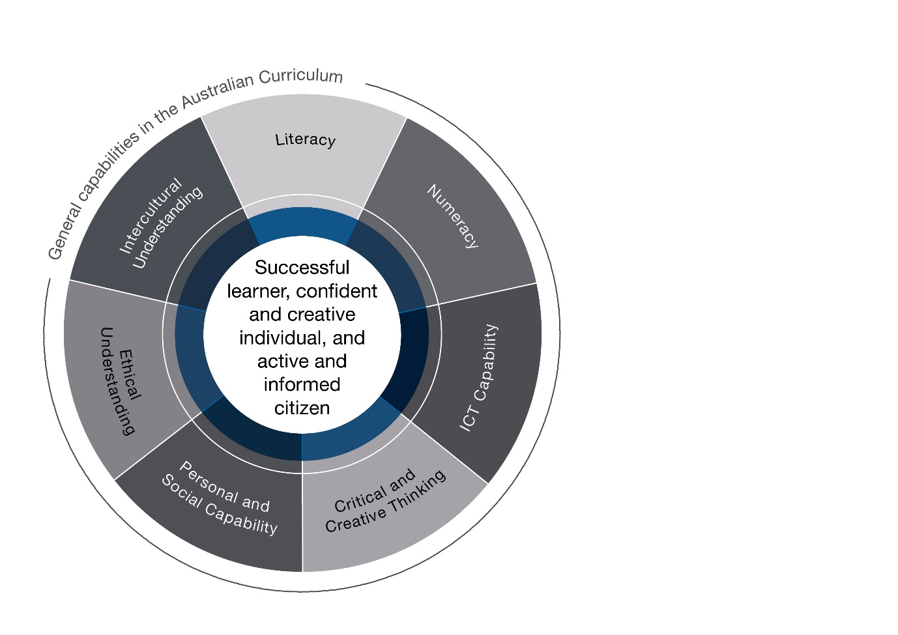

In the Australian Curriculum: English, general capabilities are identified where they are developed or applied in the content descriptions. They are also identified where they offer opportunities to add depth and richness to student learning via the content elaborations, which are provided to give teachers ideas about how they might teach the content. Icons are used to indicate where general capabilities have been identified in learning area content descriptions and elaborations.

Literacy
The Australian Curriculum: English has a central role in the development of literacy in a manner that is more explicit and foregrounded than is the case in other learning areas.
Literacy is developed through the specific study of the English language in all its spoken, written and visual forms, enabling students to become confident readers and meaning-makers as they learn about the creative and communicative potential of a wide range of subject-specific and everyday texts from across the curriculum. Students understand how the language in use is determined by the many different social contexts and specific purposes for reading and viewing, speaking and listening, writing and creating. Through critically interpreting information and evaluating the way it is organised in different types of texts, for example, the role of subheadings, visuals and opening statements, students learn to make increasingly sophisticated language choices in their own texts. The English learning area has a direct role in the development of language and literacy skills. It seeks to empower students in a manner that is more explicit than is the case in other learning areas. Students learn about language and how it works in the Language strand, and gradually develop and apply this knowledge to the practical skills of the Literacy strand in English, where students systematically and concurrently apply phonic, contextual, semantic and grammatical knowledge within their growing literacy capability to interpret and create spoken, print, visual and multimodal texts with appropriateness, accuracy and clarity.

Numeracy
Numeracy skills are addressed in the Australian Curriculum: English in important and embedded ways from Foundation to Year 10. Students use numeracy skills in the early years of schooling when they explore rhythms, syllables and sound patterns in stories, rhymes, songs and poems. In subsequent years, they learn about analytical images like figures, tables, diagrams, maps and graphs, and how they affect and complement verbal information in factual and persuasive texts. Numeracy concepts and skills are applicable when students are interpreting, analysing and creating texts involving quantitative and spatial information such as percentages and statistics, numbers, measurements and directions. When responding to or creating texts that present issues or arguments based on data, students also identify, analyse and synthesise numerical information using that understanding and textual understandings about objective and subjective language to discuss the credibility of sources.
The broad notion of texts in English includes visual and multimodal texts, the features of which may present a range of numeracy demands. Interpreting and creating visual representations requires students to examine relationships between various components of a narrative or argument and to sort information into categories including characteristics that can be measured or counted. Understanding the implied mathematical ideas behind visual organisers such as Venn diagrams and flowcharts helps students to make more effective visual choices in their own texts.

Information and Communication Technology (ICT) Capability
ICT capability is an important component of the Australian Curriculum: English. Students use ICT when they interpret and create print, visual and multimodal texts. They use communication technologies when they conduct research online, and collaborate and communicate with others electronically. In particular, they use ICT to access, analyse, modify and create hybrid, digital and multimodal texts, using digital publishing.
As students interpret and create digital texts, they develop their capability in ICT including word processing programs and other software, navigating and following research trails and selecting and evaluating information found online.

Critical and Creative Thinking
Critical and creative thinking are essential to developing analytical and evaluative skills and understandings in the Australian Curriculum: English. Students use critical and creative thinking through listening to, reading, viewing, creating and presenting texts, interacting with others, and when they recreate and experiment with literature, and discuss the aesthetic or social value of texts. Through close analysis of text and through reading, viewing and listening, students critically analyse the opinions, points of view and unstated assumptions embedded in texts. In discussion, students develop critical thinking as they share personal responses and express preferences for specific texts, state and justify their points of view and respond to the views of others.
In creating their own written, visual and multimodal texts, students also explore the influence or impact of subjective language, feeling and opinion on the interpretation of text. Students also use and develop their creative thinking capability when they consider the innovations made by authors, imagine possibilities, plan, explore and create ideas for imaginative texts based on real or imagined events. Students explore the creative possibilities of the English language to represent novel ideas.

Personal and Social Capability
There are many opportunities for students to develop personal and social capability in the Australian Curriculum: English. Students learn that language is central to personal and social identity through exploring narrative point of view and the way it shapes different interpretations and responses in readers. Using English to develop communication skills and self-expression assists students’ personal and social development as they become effective communicators, able to articulate their own opinions and beliefs and to interact and collaborate with others.
The study of English as a system helps students to understand how language functions as a key component of social interactions across all social situations. Through close reading and discussion of imaginative and persuasive texts, students experience and evaluate a range of personal and social behaviours and perspectives and develop connections and empathy with characters in different social contexts.

Ethical understanding
In the Australian Curriculum: English, students develop ethical understanding as they study the social, moral and ethical positions and dilemmas presented in a range of texts. They explore how ethical principles affect the behaviour and judgement of imagined characters in texts and the real-life experiences of those involved in similar issues and events. Students apply the skills of reasoning, empathy and imagination to consider and make judgements about actions and motives, and speculate on how life experiences affect and influence people’s decision-making and whether various positions held are reasonable.
Students studying the Australian Curriculum: English gradually understand how language use has inclusive and exclusive effects, as seen through the distinction between subjective language and bias, versus factual and objective language. They learn how language can be used to influence judgements about behaviour, speculate about consequences and influence opinions, and that language can carry embedded negative and positive connotations that can be used in ways that help or hurt others. Students use their growing understanding to create and express their own considered points of view on issues of empowerment and disempowerment in a range of imaginative and persuasive texts.

Intercultural understanding
Intercultural understanding is developed in the Australian Curriculum: English through the study of texts drawn from different historical, social and cultural contexts. Students also develop intercultural understanding from their study of the English language and the ways it has been influenced by different cultural groups, languages, speakers and writers. By engaging with literature from a wide range of cultures, students explore the role of myth, symbolism and life matters in perspectives on people and ideas, from the past and present. Through interpreting and analysing authors’ ideas and positions represented in traditional and contemporary texts in a range of media, in English or translated forms, students learn to question stated and unstated cultural beliefs and assumptions, and appreciate issues of intercultural meaning and sensitivity. In this way, students use intercultural understanding to comprehend and create a range of texts that present diverse cultural perspectives, and to empathise with a variety of people and characters in various cultural settings.

